**Director of Music & Organist/Choir Director**

**Position Description**

Christ Church Cathedral seeks enthusiastic, self-driven applicants for the part-time position of Director of Music & Organist/Choir Director.

About the Position

The Director of Music & Organist/Choir Director will own responsibility for all aspects of musical life in the Cathedral.

As the Director of Music, this position involves, among other things:

* directing one or more Cathedral choirs (including recruiting, training, rehearsing, and conducting);
* supervising and rehearsing Cathedral musicians, including choral section leaders;
* selecting liturgical music, especially from diverse music traditions ranging from Anglican musical tradition and chant to contemporary pop and Gospel;
* timely submission of all music with licensing for inclusion in worship bulletins working two weeks ahead;
* managing and adhering to copyright and licensing rights;
* overseeing the maintenance of the Cathedral’s instruments, music library, and choir vestments;
* coordinating and exploring with the choir and congregation a wide variety of expressions of music at the Cathedral;
* overseeing the maintenance of the Cathedral’s instruments;
* preparing and submit the annual draft music ministry budget and Annual Meeting report;
* managing the final music budget; and
* performing any other duties mutually agreed upon by the Dean and the Music Director & Organist.

As the Organist/Choir Director, this position involves providing music for worship, including Sunday services, Major Holy Days (if scheduled), weddings, funerals, confirmations, ordinations, and other diocesan services. The Music Director & Organist/Choir Director is responsible for securing a substitute if unavailable for any of the above. The Organist/Choir Director plans and implements a 90-minute weeknight and 45-minute Sunday morning rehearsal with choir consisting of both paid and volunteer members.

As a member of the Cathedral staff, the Director of Music & Organist/Choir Director will participate in weekly general staff meetings if possible, semi-annual staff-planning sessions, and regular meetings with the Dean among other duties.

This is a part-time position (18 hours a week, which includes rehearsals and services) that will be governed by a contract/letter of agreement reviewed annually with a mutual ministry performance review. Compensation will be based on experience, training, and education, with an annual salary within the approximate range of $45,000 to $50,000. Vacation, substitutions, and other considerations are negotiable.

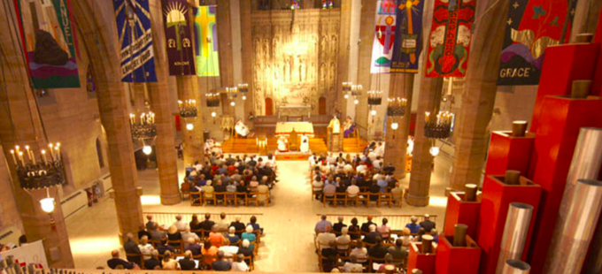

About the Cathedral

The Cathedral’s mission statement provides: “We seek a deeper relationship with God and each other in Jesus Christ through celebrating the sacraments faithfully, proclaiming the Gospel boldly, embracing diversity joyfully, and serving all passionately, as a Cathedral.” Our motto is “Be here. Be you. Be loved.”

Accordingly, we are a diverse and radically welcoming congregation. We are in our third century of ministry in the heart of downtown St. Louis and recently celebrated 150 years in our current Cathedral building. As a Cathedral, we welcome congregants and guests from throughout the region.

_______________________________________________________________

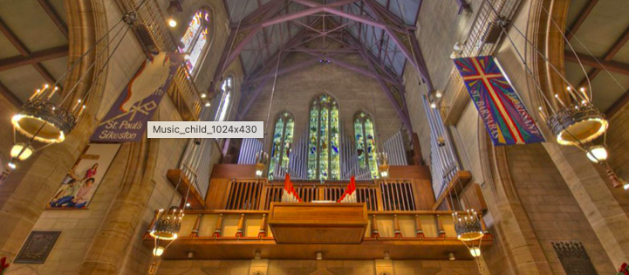

About our Instruments

Our Cathedral boasts a 5,000-pipe organ housed within in an 19th Century stone nave with a ceiling that reaches nearly 90 feet. Our Cathedral building is a national historic landmark. The combination of our magnificent organ creates an acoustic experience unique to the greater St. Louis area.

Among other instruments for accompaniment, we also proudly own a Steinway piano that has been played (and autographed) by Billy Joel and John Legend.

Christ Church Cathedral is an open and inclusive congregation, welcoming all God’s beautifully diverse people seeking to build the beloved Community. Be Here. Be You. Be Loved.

To Apply: Please submit a cover letter, resume, and list of references to cathedral Dean Kathie Adams-Shepherd at [kas@christchurchcathedral.us](mailto:kas@christchurchcathedral.us)