**St. Martin’s Episcopal Church**

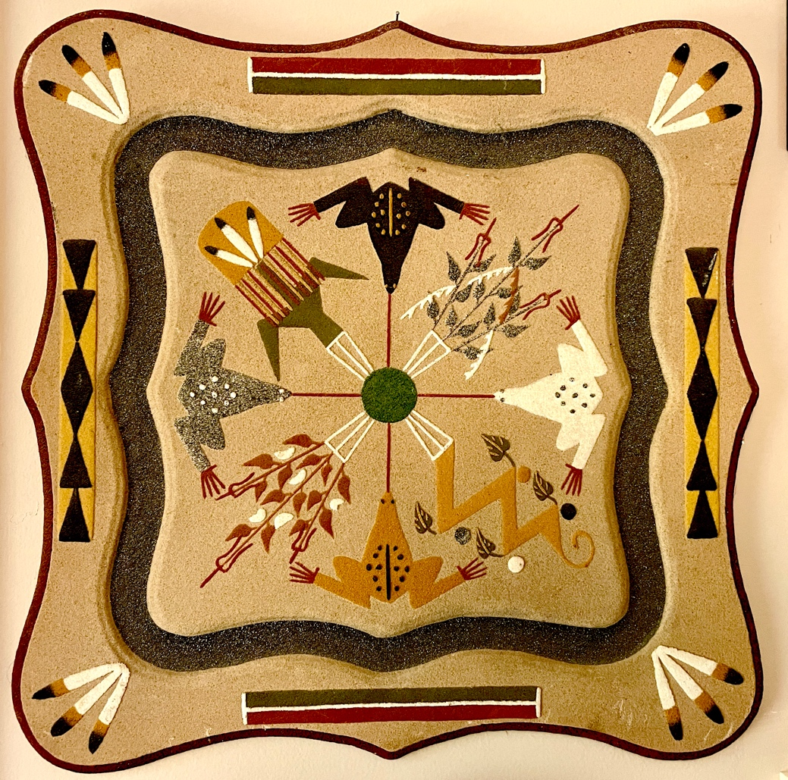

“Frogs and Four Sacred Plants,” Dine Sand Painting by Freddie Nelson

Shared Worship | Holy Communion

**“The 505****”**

Seekers, Pilgrims, Questioners, Dreamers-

We thank God for your presence!

Come as you are Enter into fellowship Open to the Holy

Sit how you are comfortable Breathe in peace and grace

See God in every face

**Saturday, November 2, 2024**

**Feasts of All Saints’/All Souls’, transferred**

**Native American Heritage Month**

& 🡪 This symbol invites you (any of you) to read aloud.

If more than one speaks, continue together.

**Centering Bell** ¥

U *As the ringing fades, we open our hearts and spirits to the sacred. You might physically make the sign of the cross, bow, or press hands together in the anjali mudra.*

**Acknowledgement for the Land** standing as able  adapted from All Saints’ Church, Minneapolis

Presider Creator, you made all people of every land. It is our responsibility to give thanks and respect to those who first occupied this land we are upon. We give thanks to--------------- , the first people of this land. We offer our respect to those ancestors who may be interred in this land. We are also thankful for the gifts of the People of the land.

**All** **Creator, let us be of good mind to reconcile the mistreatment of this land and to those who have been displaced. With thankful and respectful hearts we pray in your Name, Your Son the peacemaker, and the Sacred Spirit. Amen.**

**Opening Acclamation** standing as able  Canticle of the North Shore, Rev. Howard Anderson

Presider O give thanks to our Creator who is good

Whose love endures forever.

**All** **You sun, moon, and stars and the northern lights**

**give to our Creator thanks and praise.**

Presider Sunrise and sunset, night and day

give to our Creator thanks and praise.

**All** **Hills, valleys, wetlands and lakes, fog, rain, mist, and snow**

**give to our Creator thanks and praise.**

Presider Birch, pine, spruce and maple, moss and ferns

give to our Creator thanks and praise.

**All** **Lake trout and walleye, bass and northern,**

**loons and herons, ducks and geese**

**give to our Creator thanks and praise.**

Presider Deer, moose, cats and dogs,

eagles and sparrow, grouse and hawk

give to our Creator thanks and praise.

**All** **Young and old, women and men,**

**saints and faithful of the Great Northern Woods**

**give to our Creator thanks and praise.**

**Gathering Prayer** seated Ojibwe, The Rt. Rev. Mark McDonald

Presider Creator, we give you thanks for all you are and all you bring to us for our visit within your creation. In Jesus, you place the gospel in the Center of this Sacred Circle through which all of creation is related. You show us the way to live a generous and compassionate life.

**All** **Give us your strength to live together with respect and commitment as we grow in your spirit, for you are God, now and forever. Amen.**

**The Collect** seated

Presider God be with you.

**People And also with you.**

Presider Let us pray.

**All Almighty God, you have knit together your elect in one communion and fellowship in the mystical body of your Son Christ our Lord: Give us grace so to follow your blessed saints in all virtuous and godly living, that we may come to those ineffable joys that you have prepared for those who truly love you; through Jesus Christ our Lord, who with you and the Holy Spirit lives and reigns, one God, in glory everlasting.** **Amen.**

**First Reading** seated John 11:32-44, NRSV

Leader A reading from the Gospel according to John.

Leader When Mary came where Jesus was and saw him, she knelt at his feet and said to him,

**All "Lord, if you had been here, my brother would not have died."**

Leader When Jesus saw her weeping, and the Jews who came with her also weeping, he was greatly disturbed in spirit and deeply moved. He said, "Where have you laid him?"

**All They said to him, "Lord, come and see." Jesus began to weep.**

Leader So the religious ones said, "See how he loved him!" But some of them said, "Could not he who opened the eyes of the blind man have kept this man from dying?”

Then Jesus, again greatly disturbed, came to the tomb. It was a cave, and a stone was lying against it.

**All Jesus said, "Take away the stone." Martha, the sister of the dead man, said to him, "Lord, already there is a stench because he has been dead four days."**

Leader Jesus said to her, "Did I not tell you that if you believed, you would see the glory of God?" So they took away the stone.

And Jesus looked upward and said,

"Father, I thank you for having heard me. I knew that you always hear me, but I have said this for the sake of the crowd standing here, so that they may believe that you sent me."

**All When he had said this, he cried with a loud voice,**

**"Lazarus, come out!”**

Leader The dead man came out, his hands and feet bound with strips of cloth, and his face wrapped in a cloth. Jesus said to them, "Unbind him, and let him go."

*Pause. Breathe.*

Leader Hear what the Spirit is saying to the churches.

**All Thanks be to God.**

**The Gospel: Proclaiming the Good News!** seated

John 11:32-44,, First Nations Version of the New Testament

Leader The Holy Gospel of our Savior Jesus Christ according to John.

**People Glory to you, Lord Christ.**

*Let the precious words take root within you. In each section, see which word claims your mind or heart. Say it aloud in the pause afterward.*

Leader

When Healing Tears (Mary) found Creator Sets Free (Jesus),

she crumpled at his feet and wept.

“Wisdom Keeper!” she said *as tears ran down her face*.

“If only you had been here, my brother would still be alive.”

Creator Sets Free (Jesus) stood there watching Healing Tears (Mary) weeping at his feet. He looked around and saw all the Tribal Members who came with her also weeping.

A deep anguish began to well up inside him,

and he was troubled in his spirit.

*He cried out,* “Where did they bury him?”

“Wisdom Keeper, come with us,” they said to him. “We will show you.”

W *~~Pause; Breathe; Name the word or phrase that rings for you.~~* W

Leader

Creator Sets Free (Jesus) wept.

When the Tribal Members saw his tears, some said,

“See how deeply he cared for him!”

But others said,

“If this man could open the eyes of a blind man,

why could he not have kept this man from dying?”

Creator Sets Free (Jesus), still deep in anguish,

found his way to the family burial place.

It was a cave, and a large stone blocked the entrance.

Creator Sets Free (Jesus) cried out,

“Take away the stone!”

Head Woman (Martha) whispered to him,

“Wisdom Keeper, he has been dead for days.

There will be a terrible smell.”

He *looked at her and* said, “Do you not remember what I told you?

If you believed, you would see the shining- greatness of the Great Spirit.”

*Head Woman (Martha) could say nothing.*

*She watched as* they rolled the stone away from the burial cave.

W *~~Pause; Breathe; Name the word or phrase that rings for you.~~* W

Creator Sets Free (Jesus) turned his eyes upward toward the sky and said, “I thank you, Father, that you have already heard my prayers

and always listen to me. The reason I say this out loud

is so that all who are standing around me can hear

and believe that you sent me.”

*The men and women gathered there stood silently,*

*listening to his prayer.*

Then the voice of the Creator Sets Free (Jesus)

*pierced the silence* *as he* cried out with a loud voice,

“Creator Helps Him (Lazarus), come out of there!”

*The sound of his voice echoed from out of the burial cave*

*and then faded into the distance.*

*The people looked at Creator Sets Free (Jesus)*

*and then back at the cave.*

*No one dared to say anything, so they all waited.*

*Then suddenly, gasps could be heard from the crowd.*

*There was movement in the cave!*

Creator Helps Him (Lazarus) came *stumbling* out of the burial cave

with his ceremonial wrappings still clinging to his head hands and feet.

He was alive!

Creator Sets Free (Jesus) told the people,

“Take off his wrappings and set him free.”

W *~~Pause; Breathe; Name the word or phrase that rings for you.~~* W

Leader The Gospel of the Lord.

**All Thanks be to God.**

**The Homily: Inviting the Word Into Our Lives** Presider

**Prayers of the People for Ordinary Time** 70th General Convention, 1991

Leader Let us pray to our Creator in the name of Jesus Christ our Brother. Let us remember that everything a Native American does is in a circle, and that is because the Great Spirit always works in circles, and everything tries to be round. In the old days it was believed that all our power came to the Indian from the sacred hoop of the nation and tribe, and so long as the hoop was unbroken the people flourished. Therefore let us pray together, saying

All **Lord, mend the hoop of your people.**

Leader Everything the Great Spirit does is done in a circle. The canopy of the sky is round and the earth is round like a ball and so are all the stars. The wind, in its greatest power, whirls. Birds make their nests in circles. The sun comes forth and goes down again in a circle. The moon does the same and both are round.

All **Lord, mend the hoop of your people.**

Leader Even the seasons form a great circle in their changing, and always come back again to where they were. The life of a person is a circle from childhood to adulthood and so it is in everything where power moves. Hogans, teepees, and igloos are round like the nests of birds and they are always set in a circle and therefore the nation's hoop is a nest of many nests.

All **Lord, mend the hoop of your people.**

Leader The hoop, the circle, has been broken by hurts, wars, massacres, discrimination, and racial jokes, by stereotypes and mean words and suspicious stares. All the people have hurt others and been hurt by others. It is time to say “I'm sorry” to each other and to our creator and again make our hoop, our circle, strong.

All **Lord, mend the hoop of your people.**

Leader God be with you.

**All And also with you.**

Leader Let us pray.

Lord Jesus, you told your people: if you bring your gift to the altar and there recall that someone has anything against you, leave your gift at the altar, go first to be reconciled, make friends with that person again, and come and offer your gift. We come now to you as a family in need of your mercy and love. We ask you to bring peace to our conflicts with charity to those we have offended.

All **Lord, mend the hoop of your people.**

Leader For the times we have failed to love and forgive others,

All **Lord, mend the hoop of your people.**

Leader For the times we have failed to ask forgiveness,

All **Lord, mend the hoop of your people.**

Leader For the times we have made fun of others, especially because of racial and cultural difference,

All **Lord, mend the hoop of your people.**

Leader In intercession for those who are part of this Christian community and yet not present with us this day, we pray for the sick and the infirm; for those who have departed this life; and for the unevangelized. We give you thanks for making us one in the spirit through prayer.

All **Lord Christ, we thank you for having mended the hoop of your people.**

Leader We offer up these petitions and thanksgivings in the name of our Savior Jesus Christ even as we pray together:

*Silence*

X

(Leader reads names of those on our prayer list:

Carolann, Helen, Virginia, Susan, Sandy, Ruth, Linda, Ruth, Russ, Dan, and Janet; the people of Ukraine; We pray for John who has died, and his wife Ellen and sons Brian and Michael in their grief; please add your own concerns and thanksgivings)

X

**All Lord God, creator of all things and all peoples, may we now walk in a circle of love and power. Let us be like rays of light, like flowers bright with light, like a great tree mighty in the roots, mighty in the top, that reaches the sky where the leaves catch the light, and sing with the wind a song of the circle. Let our life be like the rainbows whose colors teach us unity. Let us, Almighty God, follow the great circle, the roundness of power, and be at one with the moon and the sun and the circling ripples of water. We ask it in Jesus’ name. AMEN.**

**The Peace** standing as able, then greet each other with a bow or wave or anjali mudra

Presider The peace of God be always with you,

**People And also with you.**

{{*Greet one another in the name of Christ.* {{

**Offering**

*As the table is prepared for Holy Communion, gifts of bread and wine are brought up by members of the congregation to the chapel altar. At this time, we also pass the offering plate to present our monetary offerings to God out of gratitude. Once the table is prepared, we ask the congregation to rise and acknowledge our gratitude and offerings to God with these words:*

*Priest* All things come from you, O Lord.

*People* **We offer our gifts in return**

**just as our elders and ancestors teach us.**

**It is through this sharing of what we have to give**

**that we have found strength beyond imagining. Amen.**

**THE HOLY COMMUNION**

(written by the Rev. Canon Debbie Royals, Pasca Yaqui, or the Diocese of Arizona, who holds the copyright but has granted us her gracious permission for its use).

(Children are always welcome to come forward to see.)

**The Great Thanksgiving** standing as able

Presider Creator God be with you.

**People And also with you.**

Presider Let your hearts sing.

**People We lift our voices in preparation for this ceremony.**

Presider Let us give thanks to Creator.

**People It is right to give our thanks and praise.**

*The people may sit. The Presider continues*

From the place of the rising sun in the East

to the South where the warm winds blow,

from the West where soft rain comes

and to the coldness of the North

we unite with all creation from the four directions

to join our voices

in songs of thanksgiving and praise

for the gift of your son, Jesus Christ,

our Elder Brother.

With hearts lifted, we join with our ancestors

who taught us to pray as they have prayed

since the beginning of time:

**ALL Holy, holy, holy Lord, God of power and might. Heaven and earth are full of your glory. Hosanna in the highest. Blessed is the one who comes in the name of the Lord. Hosanna in the highest.**

Presider

O Great Spirit, Our Creator,

you gave us the gift of ceremony;

you taught us that everything is sacred

and you asked us to walk with you

on a path towards peace and love.

Just as in generations past,

like our grandfathers grandmothers,

we come humbly

with arms outstretched

to honor you

and all that you have created

for all of creation.

Together with all creation

we live interdependently,

and marveling that when we do,

creation serves as its best reflection

of the awesome wonder that you are in our eyes.

You have always cared for us,

even when it seemed that there was no way

to save our misuse of creation and mistreatment of each other.

Many years ago,

you came to us as a human being

so that we might understand you

in a way that would help us find the path you had intended for us.

Our Elder Brother, Jesus, as he was called,

came into creation in the same way that all humanity is born

because people had turned away from you

and no longer loved each other,

bringing death and destruction to all.

Sharing our living and dying,

our Elder Brother Jesus opened our eyes and our hearts

to understand that we are all relatives

and that you, our Creator, love us all.

Jesus lived in a good way.

He rejected no one,

fed the hungry,

gave water to the thirsty,

and broke down the barriers that had been created

between race, class, and sex.

But, he paid a price for his loving ways.

When it was his time,

he stretched out his arms upon the cross and died.

In this sacrifice

our Elder Brother Jesus united us in all that is beauty,

with all that has been and all that will ever be.

*(At these words the Presider holds the bread and says)*

On the night before He died,

he gave us another ceremony.

He gathered those who had been closest to him for a meal.

During the meal our Elder Brother Jesus took bread,

gave thanks to you, blessed it, broke it,

and gave it to his friends, and said:

“Take, eat: This is my Body, which is given for you.   
 Do this for the remembrance of ME.”

R *bells ring* R

*(At these words the Presider lifts the cup and says)*

After supper our Elder Brother Jesus took the cup of wine,

gave thanks to you, blessed it,

gave it to his friends, and said:

“Drink this, all of you:

This cup is the new Covenant in my Blood,  
poured out for you and for all

for the forgiveness of sins.

Do this for the remembrance of me.”

R *bells ring* R

We found it hard to understand these words and actions,

but we followed the path celebrating this ceremony

from that time until now.

Through our experiences then we proclaim this mystery of faith:

**All Christ has died; Christ is risen; Christ will come again.**

In this ceremony that our Elder Brother Jesus gave us,

we have experienced a transformation of our spirits.

We have been brought into the death of Jesus

and raised into his resurrection,

and we eat and drink with him in his new life.

We have noticed that when we come together for this ceremony,

we all leave nurtured and nourished

no matter how lost we feel

and no matter how hungry we have been.

Presider *(touching bread and wine)*

We also offer our gifts in return

just as our elders and ancestors teach us.

It is through this sharing of what we have to give

that we have found strength beyond imagining.

**All**

**So, now once again,**

**we humbly call upon your spirit,**

**we cry for a vision.**

**Feed us,**

**quench our thirst,**

**make these simple elements from your creation**

**to be Christ's body and Christ's blood.**

**We cry for the vision**

**that will help us to be your holy people**

**in all that we do,**

**in all that we see,**

**in all that we hear,**

**in all that we breathe**

**and in all that we speak.**

U Come Creator Spirit.

Come now and be for us the holy food and drink

that your people cry out for in this ceremony.

Surrounded now by our ancestor spirits,

the spirits of those who have led saintly lives,

like Martin, David Oakerhater, Enmegahbowh,

King Kamehameha and Queen Emma, and Matoaka,

and all your Saints and angels,

we celebrate with all of creation –

the two legged, the four legged, the winged,

those that crawl and those that swim,

those that give shade and those that offer us pleasing aromas –

for together we see the awesome nature of all creation,

the need to be one family living in relationship,

interdependently and yet as one.

May we be this unity and live as relatives to all.

Through Jesus the Christ

and with Jesus the Christ

and in Jesus the Christ,

made possible by your Holy Spirit,

we join with you our God and Creator

as a community of relatives.

**All Blessed are you now and for ever. AMEN.**

R *bells ring* R

Presider

And now, as Jesus taught us, we pray:

**The Lord’s Prayer** (Standing, in unison) Nez Perce

**O Great Spirit, Creator of the Universe,**

**You are our Shepherd Chief in the most high place**

**Whose home is everywhere, even beyond the stars and moon.**

**Whatever you want done, let it be done everywhere.**

**Give us your gift of bread day by day.**

**Forgive our wrongs as we forgive those who wrong us.**

**Take us away from wrong doings.**

**Free us from all evil, for everything belongs to you.**

**Let your power and glory shine forever. Amen.**

**Fraction Anthem**

Presider Alleluia. We break this bread to share in the Body.

**All We who are many are one Body,**

**For we all share in the one bread. Alleluia.**

*At Communion, all are invited to come forward. If you would like the host to be intincted, please indicate so and it will be placed in your hand. Communion in one kind is a complete sacrament.*

**Prayer After Communion**

Presider Let us pray.

**All We thank you, Creator God, for feeding us,**

**nurturing us and reminding us**

**that you are ever present, our companion.**

**As we leave this Sacred Circle,**

**may we carry away the memory of this time together**

**so that we may continue in the risen life of Christ,**

**the one who comes**

**that all people might live with dignity and in peace. AMEN.**

**Announcements- Birthdays-- Anniversaries**

**Benediction** Shinnecock

Presider

O Great Spirit, who has filled the world with beauty,

open our eyes to behold thy gracious hand,

in all thy work keep our hearts thankful and our vision clear,

as we seek to fulfill your blessings.  
And the blessing of God Almighty,

U the Creator, the Sanctifier, and the Inspirer,U

rest upon you, this day and every day. **Amen.**

**Centering Bell** ¥

*As the sound of the bell fades, you may raise your arms, blessing those around you. Breathe in: accept both the challenges and blessings of this Holy Communion and let it soak deep into your heart, hands, and wills.*

**Explanation of symbols:**

¥-- Ring large bell U -- Make sign of cross

&-- read aloud if you wish R –Ring sanctus bells

**St. Martin’s Episcopal Church**

15764 Clayton Rd. • Ellisville, Missouri 63011

Phone: 636.227.1484

http://stmartinschurch.org

[www.facebook.com/stmartinschurch](http://www.facebook.com/stmartinschurch)

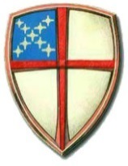

The Rt. Reverend Deon Kevin Johnson, *Bishop of Missouri*

The Rev. Leslie Barnes Scoopmire, *Rector,* [*lscoopmire@stmartinschurch.org*](mailto:lscoopmire@stmartinschurch.org)

Janet Theiss, *Parish Administrator, jtheiss@stmartinschurch.org*

Denise Marsh, *Music Director, dmarsh@stmartinschurch.org*

Scott Scoopmire, *Communications Director, communications@stmartinschurch.org*

**The Vestry**

John Alden (2025) Greg Andersen (2026)

Jeanne King (2025) John Limbaugh (2026)

Beckie Strobel (2025) Kim Montgomery (2026)

Chelsea Brewer (2027) Scott Shearer (2027)

Nancy Scheibal (2027)

**Convention Delegates**

Rina Chittooran (2025) John Alden (alternate-2026)

Becky Brewer (2026)

*\*Date in parentheses is the end of the term of service in January of the year noted.*