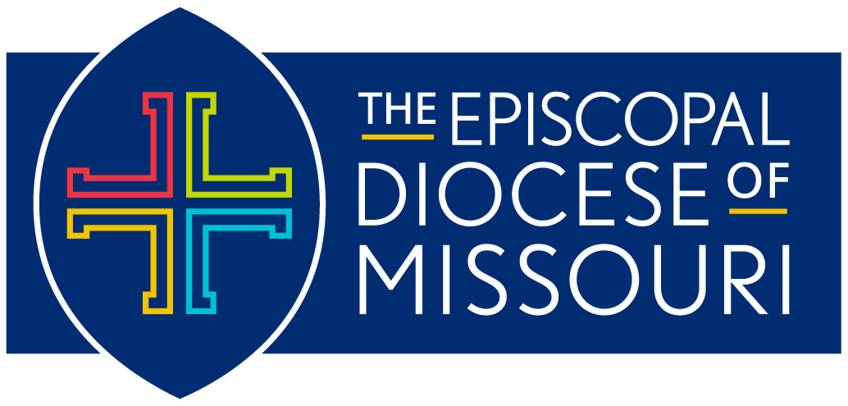
Diocese of Missouri Prayer Cycle
Third Quarter 2024:
July 2024 – September 2024

The Revised Common Lectionary: Year B
Office Lectionary: Year Two

The Anglican Cycle of Prayer is available online at
https://www.anglicancommunion.org/resources/cycle-of-prayer/download-the-acp.aspx

*Please note:
In an effort to keep our diocesan list as current as possible, we will be distributing the prayer cycle by quarters this year:
- January, February, March (released January, 2024)
- April, May, June (released March, 2024)
- July, August, September (released June 2024)
- October, November December (released September 2024)

July 7: The Seventh Sunday after Pentecost
In our Diocese of Missouri, we pray for the people and ministry of St. Mark’s Episcopal Church (1939) in St. Louis and Michael, their Interim Priest-in-Charge; Jerre, their Deacon; and Teresa, their Priest Associate.
- In our companion Diocese of Puerto Rico, we pray for Saint Mary Virgin Helped Parish (Parroquia Ayudada Santa María Virgen) in Ponce.
- In the Anglican Communion, we pray for the people and ministry of the Church of the Province of the Indian Ocean.

July 14: The Eighth Sunday after Pentecost
In our Diocese of Missouri, we pray for the people and ministry of St. Paul’s Episcopal Church (1947) in Sikeston and Edie, their priest.
- In our companion Diocese of Puerto Rico, we pray for Mission San Marcos Evangelista (Misión San Marcos Evangelista) in Ponce.
- In the Anglican Communion, we pray for the Church of Ireland.

July 21: The Ninth Sunday after Pentecost
In our Diocese of Missouri, we pray for St. Barnabas Episcopal Church (1957) in Florissant and Dave, their Priest-in-Charge.
- In our companion Diocese of Puerto Rico, we pray for Reconciliation Helped Parish (Parroquia Ayudada La Reconciliación) in Ponce.
- In the Anglican Communion, we pray for the Nippon Sei Ko Kai.

July 28: The Tenth Sunday after Pentecost
In our Diocese of Missouri, we pray for the Episcopal Church of the Advent (1957) in Crestwood and Emily, their Rector.
- In our companion Diocese of Puerto Rico, we pray for Holy Name of Jesus Helped Parish (Parroquia Ayudada Santo Nombre de Jesús) in Ponce.
- In the Anglican Communion, we pray for the Episcopal Church in Jerusalem & the Middle East.

August 4: The Eleventh Sunday after Pentecost
In our Diocese of Missouri, we pray for Camp Phoenix. We pray for Erin, the camp’s director, along with all staff members, camp counselors, and campers beginning their adventure today at Camp Wyman in Eureka.
- In our companion Diocese of Puerto Rico, we pray for New Mission The Child Jesus (Nueva Misión El Niño Jesús) in Quebradilla.
- In the Anglican Communion, we pray for the Anglican Church of Kenya.

August 11: The Twelfth Sunday after Pentecost
In our Diocese of Missouri, we pray for St. Timothy’s Episcopal Church (1960) in Creve Coeur. We pray for Meghan, their Rector.
- In our companion Diocese of Puerto Rico, we pray for Mission Santa Ana (Misión Santa Ana) in Sábana Grande, and Maritza, their Vicar.
- In the Anglican Communion, we pray for the Anglican Church of Korea.

August 18: The Thirteenth Sunday after Pentecost
In our Diocese of Missouri, we pray for the people and ministry of Rockwell Episcopal Campus Ministry in St. Louis and Hopie, their chaplain. We pray for all students returning to school.
- In our companion Diocese of Puerto Rico, we pray for Divino Salvador Chapel (Capilla Divino Salvador) in Old San Juan.
- In the Anglican Communion, we pray for the Anglican Church of Melanesia.

August 25: The Fourteenth Sunday after Pentecost
In our Diocese of Missouri, we pray for the people and ministry of St. Martin’s Episcopal Church (1965) in Ellisville and Leslie, their Rector.
- In our companion Diocese of Puerto Rico, we pray for La Encarnacion Parish (Parroquia La Encarnatión) in San Juan.
- In the Anglican Communion, we pray for La Iglesia Anglicana de Mexico.

September 1: The Fifteenth Sunday after Pentecost
In our Diocese of Missouri, we pray for the people and ministry of All Saints’ Episcopal Church (1979) in Farmington and Richard, their Vicar.
- In our companion Diocese of Puerto Rico, we pray for Mission San Francisco de Asís (Misión de Asís) in San Juan.
- In the Anglican Communion, we pray for Igreja Anglicana de Mocambique e Angola.

September 8: The Sixteenth Sunday after Pentecost
In our Diocese of Missouri, we pray for the people and ministry of The Episcopal Church of the Transfiguration (1991) in Lake St. Louis. We pray for Lu-Anne, their Rector; and Meg, their Curate.
- In our companion Diocese of Puerto Rico, we pray for Saint John the Baptist Assisted Parish (Parroquia Ayudada Saint john the Baptist) in San Juan.
- In the Anglican Communion, we pray for the Church of the Province of Myanmar (Burma).

September 15: The Seventeenth Sunday after Pentecost
In our Diocese of Missouri, we pray for the people and ministry of St. Francis Episcopal Church (1991) in Eureka. We pray for Laurie, their Rector; and David, their Deacon.
- In our companion Diocese of Puerto Rico, we pray for San Juan Bautista Helped Parish (Parroquia Ayudada San Juan Bautista) in San Juan.
- In the Anglican Communion, we pray for the Church of Nigeria.

September 22: The Eighteenth Sunday after Pentecost
In our Diocese of Missouri, we pray for the people and ministry of St. Vincent’s-in-the-Vineyard Episcopal Church (2008) in Ste. Genevieve and Warren, their priest.
- In our companion Diocese of Puerto Rico, we pray for San José Helped Parish (Parroquia Ayudada San José) in San Juan.
- In the Anglican Communion, we pray for the Church of North India (United).

September 29: The Nineteenth Sunday after Pentecost
In our Diocese of Missouri, we pray for the people and ministry of Faith Christian Church of India (2018) in Ballwin. We pray for Clive and Sujanna, their priests.
- In our companion Diocese of Puerto Rico, we pray for Mission Cristo Redentor (Misión Cristo Redentor) in San Sebastián.
- In the Anglican Communion, we pray for the Church of Pakistan (United).

