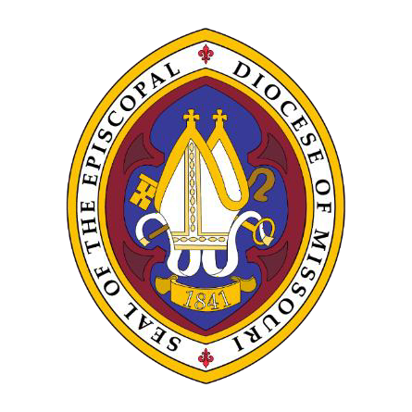The Celebration of
 Page 1 

The Holy Eucharist
Together with the Renewal of
Baptismal and Ordination Vows

The Right Reverend Deon K. Johnson,
The Episcopal Bishop of Missouri, Presider

The Reverend Susan Candea,
The E.L.C.A. Bishop of the Central States Synod, Preacher

Monday of Holy Week
11:00 A.M., MONDAY, APRIL 11, 2022

St. Timothy’s Episcopal Church
St. Louis, Missouri

Welcome

Scattered into the world we gather together as God's people in worship. We bring the fragments of our lives to be healed and made whole in Christ as we gather in community. We gather to be renewed in our commitment to follow Jesus. We gather from intimate rural parishes and sprawling urban ones, long-time church members, and those new to the faith to celebrate a new verse in a song that has been ringing through eternity. As we gather, we bring our diverse gifts: gifts of music, dance, prophecy, teaching, preaching, and friendship. We present these gifts in the form of our most precious offering to God, our very selves, that all that we do may be for God’s
glory in the unity of Christ’s church.

Land Acknowledgement

We respectfully recognize and acknowledge that we are on the traditional, ancestral lands of the Osage Nation. The process of acknowledging the land we stand on is a way of accepting our complicity in a process of colonization that removed the Osage people from their ancestral lands. We also make this acknowledgment to affirm our commitment to stand with indigenous communities today as they seek justice and resist continued threats to their sovereignty and humanity.

We are also cognizant that we cannot separate the history of The Episcopal Church from the history of colonialism and slavery in the United States. Four hundred plus years ago, the first enslaved Africans were brought to the Americas. We acknowledge the legacy of slavery in this area, and the blood, sweat, and tears of enslaved people that soak the earth beneath our feet in Missouri. This legacy persists today as we continue to work towards racial justice, equity, liberation, and community, here in Missouri and across The Episcopal Church.

We love pictures and videos, and we love sharing what we do on social media. When attending Diocesan events or services, you agree to our using pictures of you and any children in your charge on social media and elsewhere. If you prefer not to be included in photos or video, please inform a staff member or usher before we start taking pictures or video.

The Celebration of the Holy Eucharist
Together with the Renewal of Baptismal & Ordination Vows

The GATHERING of GOD’S PEOPLE: PRELUDE

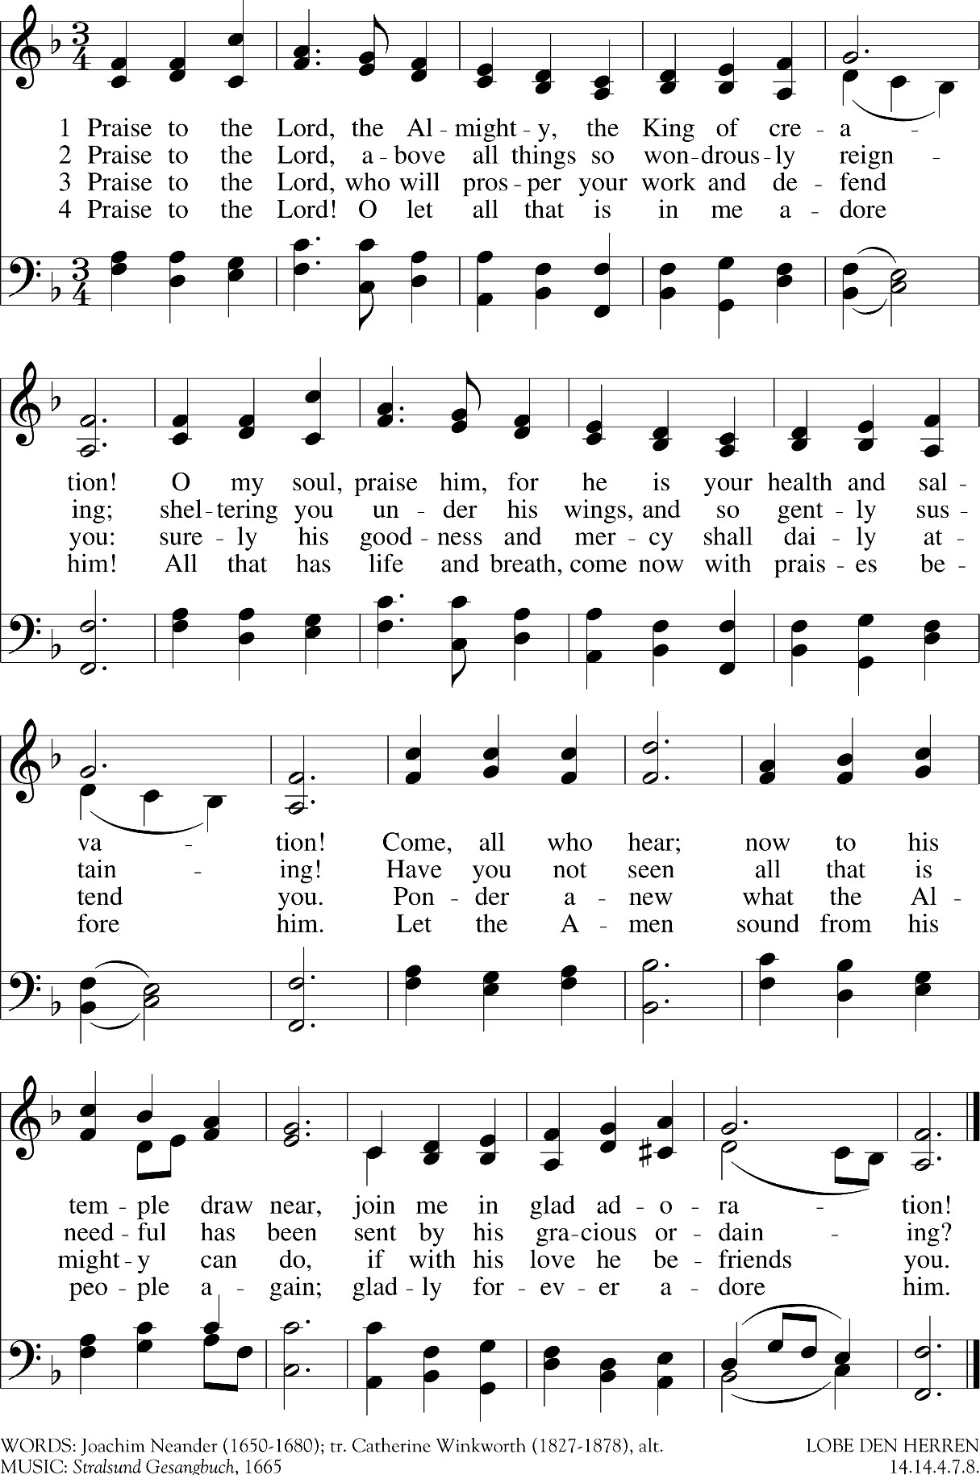
ENTRANCE: “PRAISE TO THE LORD, THE ALMIGHTY”

Opening Acclamation
Bishop Blessed be the one, holy, and living God:
People Glory to God for ever and ever. Amen. Bishop There is one Body and one Spirit; People There is one hope in God’s call to us; Bishop One Lord, One Faith, One Baptism; People One God and Creator of all.

Bishop The Lord be with you.
People And also with you.
Bishop Let us pray.
Silence is kept for a time.
Almighty God, whose most dear Son went not up to joy but first, he suffered pain, and entered not into glory before he was crucified: Mercifully grant that we, walking in the way of the cross, may find it none other than the way of life and peace; through Jesus Christ your Son our Lord, who lives and reigns with you and the Holy Spirit, one God, for ever and ever. Amen.

The Liturgy of the Word
OLD TESTAMENT LESSON 1 SAMUEL 3:1-10
T
he boy Samuel ministered before the Lord under Eli. In those days the word of the Lord was rare; there were not many visions. One night Eli, whose eyes were becoming so weak that he could barely see, was lying down in his usual place. The lamp of God had not yet gone out, and Samuel was lying down in the house of the Lord, where the ark of God was. Then the Lord called Samuel. Samuel answered, “Here I am.” And he ran to Eli and said, “Here I am; you called me.” But Eli said, “I did not call; go back and lie down.” So he went and lay down. Again the Lord called, “Samuel!” And Samuel got up and went to Eli and said, “Here I am; you called me.” “My son,” Eli said, “I did not call; go back and lie down.” Now Samuel did not yet know the Lord: The word of the Lord had not yet been revealed to him. A third time the Lord called, “Samuel!” And Samuel got up and went to Eli and said, “Here I am; you called me.” Then Eli realized that the Lord was calling the boy. So Eli told Samuel, “Go and lie down, and if he calls you, say, ‘Speak, Lord, for your servant is listening.’” So Samuel went and lay down in his place. The Lord came and stood there, calling as at the other times,
“Samuel! Samuel!” Then Samuel said, “Speak, for your servant is listening.”

Reader: Hear what the Holy Spirit is telling God’s people.
People Thanks be to God.

The Psalm of the Day: Psalm 63:1-8
V. O God, you are my God; eagerly I seek you;
R. my soul thirsts for you, my flesh faints for you,
as in a barren and dry land where there is no water.

V. Therefore I have gazed upon you in your holy place,
R. that I might behold your power and your glory.

V. For your loving-kindness is better than life itself;
R. my lips shall give you praise.

V. So will I bless you as long as I live,
R. and lift up my hands in your name.

V. My soul is content, as with marrow and fatness,
R. and my mouth praises you with joyful lips,

V. when I remember you upon my bed,
R. and meditate on you in the night watches.

V. For you have been my helper,
R. and under the shadow of your wings I will rejoice.

V. My soul clings to you;
R. your mighty hand holds me fast.

NEW TESTAMENT LESSON EPHESIANS 4:11-16
S
o Christ himself gave the apostles, the prophets, the evangelists, the pastors and teachers, to equip his people for works of service, so that the body of Christ may be built up until we all reach unity in the faith and in the knowledge of the Son of God and become mature, attaining to the whole measure of the fullness of Christ. Then
we will no longer be infants, tossed back and forth by the waves, and blown here and there by every wind of teaching and by the cunning and craftiness of people in their deceitful scheming. Instead, speaking the truth in love, we will grow to become in every respect the mature body of him who is the head, that is, Christ. From him the whole body, joined and held together by every supporting ligament, grows and builds itself up in love, as each part does its work.

Reader: Hear what the Holy Spirit is saying to the Church.
People Thanks be to God.

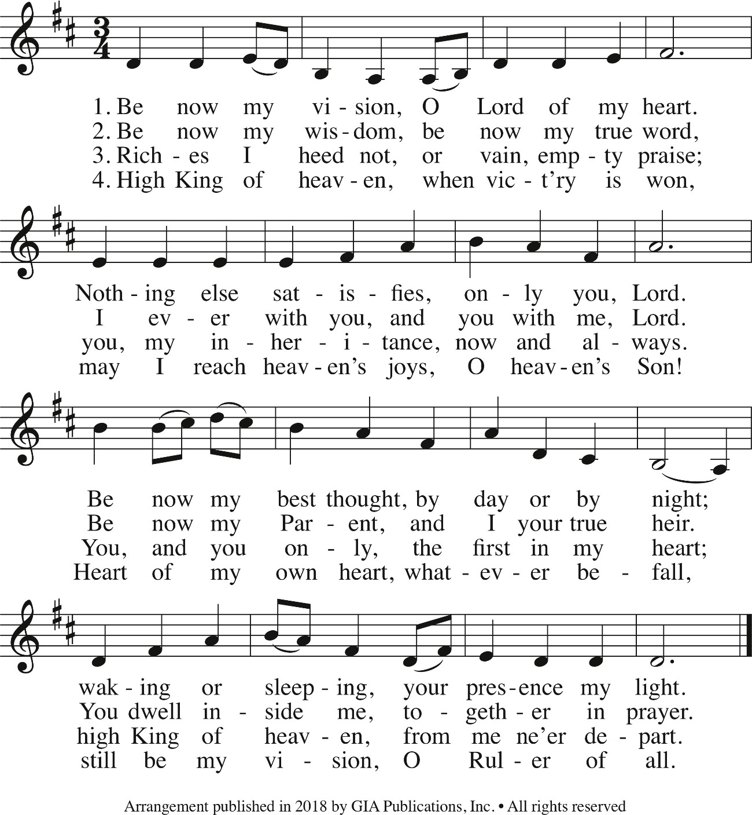
THE SEQUENCE: “BE NOW MY VISION”

Gospel Matthew 9:35-38
Deacon: The Holy Gospel of our Lord Jesus Christ according to Matthew.
People Glory to you, Lord Christ.
J
esus went through all the towns and villages, teaching in their synagogues, proclaiming the good news of the kingdom and healing every disease and sickness. When he saw the crowds, he had compassion on them, because they were harassed and helpless, like sheep without a shepherd. Then he said to his disciples, “The
harvest is plentiful but the workers are few. Ask the Lord of the harvest, therefore, to send out workers into his harvest field.”

Deacon: The Gospel of the Lord.
People Praise to you, Lord Christ.
THE SERMON BISHOP SUSAN CANDEA

A period of silence follows the sermon.

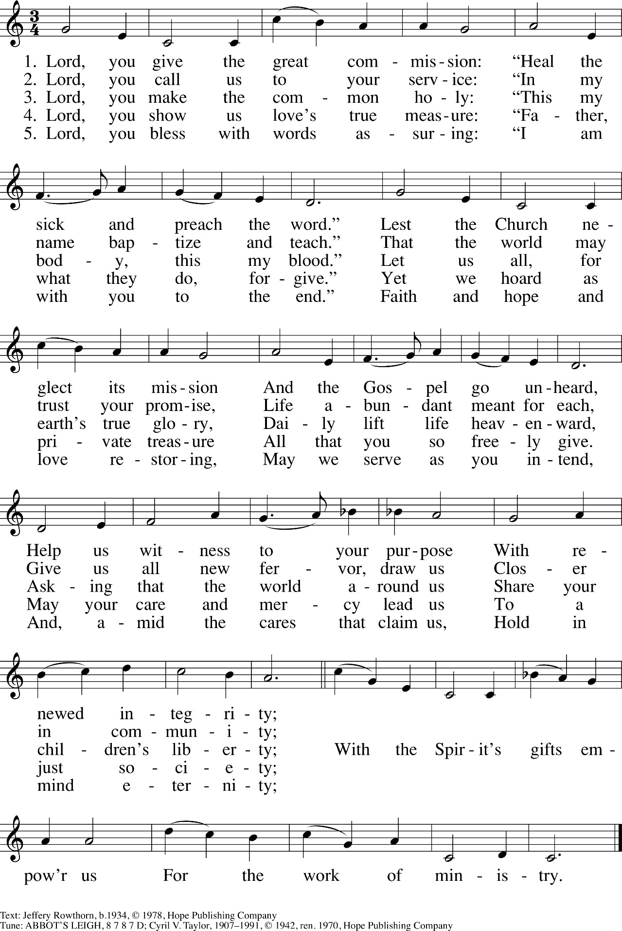
Hymn of the Day

Renewal of Baptismal Vows

The Bishop invites the community to renew their Baptismal Vows.
Bishop Do you renounce the devil and all the forces that defy God, the powers of this world that rebel against God, and the ways of sin that draw you from God?
People I renounce them.

The presiding minister addresses the assembly. Bishop Do you believe in God the Father? People I believe in God, the Father almighty,
creator of heaven and earth.

Bishop Do you believe in Jesus Christ, the Son of God?
People I believe in Jesus Christ, God’s only Son, our Lord, who was conceived by the Holy Spirit,
born of the virgin Mary, suffered under Pontius Pilate,
was crucified, died, and was buried; he descended to the dead.
On the third day he rose again; he ascended into heaven,
he is seated at the right hand of the Father,
and he will come to judge the living and the dead.

Bishop Do you believe in God the Holy Spirit?
People I believe in the Holy Spirit,
the holy catholic church, the communion of saints, the forgiveness of sins,
the resurrection of the body, and the life everlasting.

Bishop You have made public profession of your faith. Do you intend to continue in the covenant God made with you in holy baptism:
to live among God’s faithful people,
to hear the word of God and share in the Lord’s supper,
to proclaim the good news of God in Christ through word and deed, to serve all people, following the example of Jesus,
and to strive for justice and peace in all the earth?
People I do, and I ask God to help and guide me.

The Bishop addresses the assembly.
People of God, do you promise to support and pray for each other in their life in Christ?
We do, and we ask God to help and guide us.

The presiding minister prays for God’s blessing. Bishop Let us pray.
Silence is kept.

Bishop We give you thanks, O God, that through water and the Holy Spirit you give us new birth, cleanse us from sin, and raise us to eternal life. Stir up in us the gift of your Holy Spirit: the spirit of wisdom and understanding, the spirit of counsel and might, the spirit of knowledge and the fear of the Lord, the spirit of joy in your presence, both now and forever. Amen.

The Renewal of Ordination Vows
The Bishops sit before the Altar and addresses clergy who are to renew their vows. They stand facing the Bishop, who says:
Bishop Dear friends, the ministry we share is none other than the sacrificial ministry of Christ, who gave himself up to death on the cross for the salvation of the world. By his glorious resurrection he has opened for us the way of everlasting life. By the gift of the Holy Spirit he shares with us the riches of his grace. We are called to proclaim his death and resurrection, to administer the Sacraments of the New Covenant which he sealed with his blood on the cross, and to care for his people in the power of the Spirit.

Bishop Do you here, in the presence of Christ and his Church, renew your commitment to your ministry, under the pastoral direction of your bishop?
Clergy I do.

Bishop Do you reaffirm your promise to give yourself to prayer and study?
Clergy I do.

Bishop Do you reaffirm your promise so to minister the Word of God and the Sacraments of the New Covenant that the reconciling love of Christ may be known and received?
Clergy I do.

Bishop Do you reaffirm your promise to be a faithful servant of all those committed to your care, patterning your life in accordance with the teachings of Christ, so that you may be a wholesome example to your people?
Clergy I do.

The Bishops stand and make this affirmation
Bishops And now, as your bishop, I, too, before God and you, re-dedicate myself and reaffirm the promises that I made when I was ordained. I ask your prayers.
Bishop and Clergy
May the Lord who has given us the will to do these things, give us also the grace and power to perform them.

The Prayers of the People
Deacon With the whole people of God in Christ Jesus, let us pray for the church, those in need, and all of God's creation.

Leader For the holy catholic church, that, filled with your love, it may hunger for truth and thirst after righteousness: God of mercy,
People Hear our prayer.

Leader For all members of the church, that they may serve you in true and godly lives: God of mercy,
People Hear our prayer.

Leader For all Bishops, Priests, and Deacons, that, sustained by your Holy Spirit, they may carry out their ministry with joy and a spirit of bold trust, serve your people, build up your church, and glorify your name: God of mercy,
People Hear our prayer.

Leader For the peace of the church, that our divisions may be overcome, so that, united in Christ, we may serve the world and bear witness to the Good News: God of mercy,
People Hear our prayer.

Leader For the nations of the world and their leaders, that they may work for justice and promote the dignity and freedom of every person: God of mercy,
People Hear our prayer.

Leader For the whole creation, that everything you have made may fulfill your purpose and that we may exercise care for your diverse gifts: God of mercy,
People Hear our prayer.

Leader For the poor, the persecuted, the sick, the lonely, the forgotten, and all who suffer; for refugees, prisoners, and all who are in danger; that they may be relieved and protected: God of mercy,
People Hear our prayer.

Leader For the glorious company of all the saints, those who have died in faith and those who live in certain hope, we praise you. That their witness may give us courage until the day of Jesus Christ: God of mercy,
People Hear our prayer.

Bishop Almighty God, the giver of all good gifts, in your divine providence you have appointed various orders in your Church: Give your grace, we humbly pray, to all who are called to any office and ministry for your people; and so fill them with the truth of your doctrine and clothe them with holiness of life, that they may faithfully serve before you, to the glory of your great Name and for the benefit of your holy Church; through Jesus Christ our Lord, who lives and reigns with you, in the unity of the Holy Spirit, one God, now and for ever. Amen.

The Peace
Bishop The peace of Christ be always with you.
People And also with you.
Then the Ministers and the People may greet one another in the name of the Lord.

Gathering at Christ’s Table

Offertory Sentence
The Bishop says
Offer to God a sacrifice of thanksgiving, and make good your vows to the Most High. Psalm 50:14

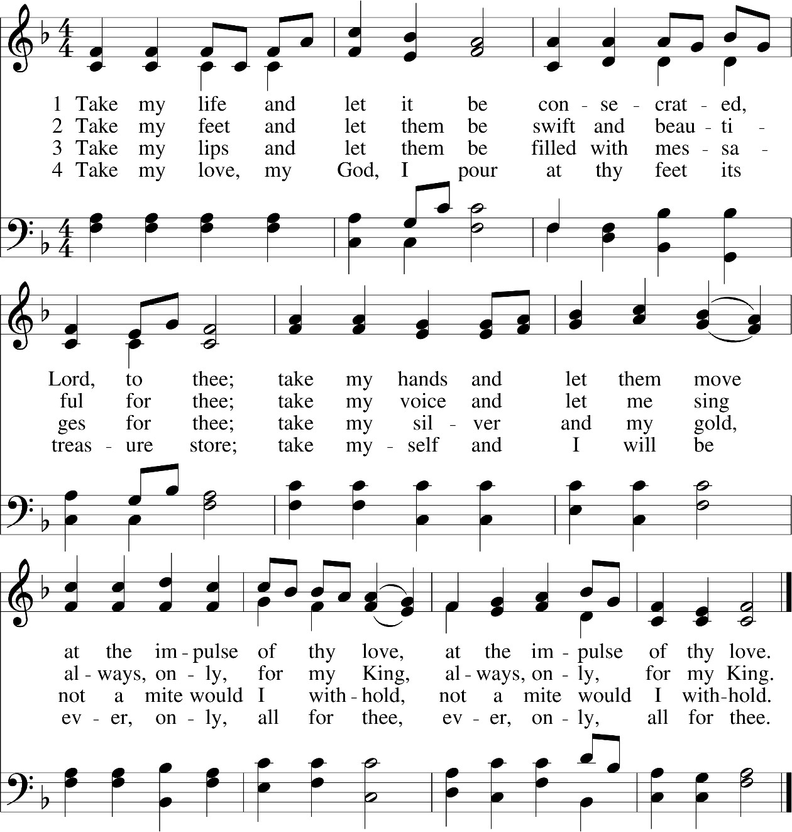
Offertory Hymn: “Take My Life and Let It Be”

The Great Thanksgiving

The EUCHARISTIC PRAYER: ENRICHING our WORSHIP
The Bishop goes to the Lord’s Table as the chief Presider and, joined by other bishops and presbyters, proceeds with the celebration of the Eucharist. All stand as they are able.

Bishop God is with you. Obispo El Señor sea con ustedes.
People And also with you. Pueblo Y con tu espíritu.
Bishop Lift up your hearts. Obispo Elevemos los corazones.
People We lift them to the Lord. Pueblo Los elevamos al Señor.
Bishop Let us give thanks to the Lord our God. Obispo Demos gracias a Dios nuestro Señor.
People It is right to give thanks and praise. Pueblo Es justo darle gracias y alabanza.

The Bishop continues with the Eucharistic Prayer.
Bishop All thanks and praise are yours at all times and in all places, our true and loving God; through Jesus Christ, your eternal Word, the Wisdom from on high by whom you created all things. You laid the foundations of the world and enclosed the sea when it burst out from the womb; You brought forth all creatures of the earth and gave breath to humankind. Wondrous are you, Holy One of Blessing, all you create is a sign of hope for our journey; And so as the morning stars sing your praises we join the heavenly beings and all creation as we shout with joy:

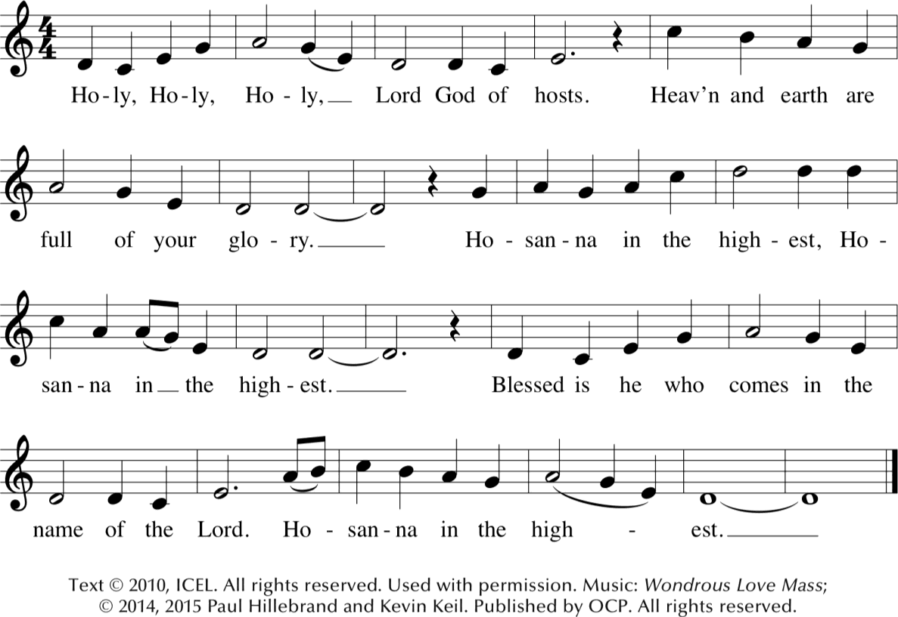
SANCTUS: WONDROUS LOVE MASS
The Bishop continues
Bishop Glory and honor are yours, Creator of all, your Word has never been silent; you called a people to yourself, as a light to the nations, you delivered them from bondage and led them to a land of promise. Of your grace, you gave Jesus to be human, to share our life, to proclaim the coming of your holy reign and give himself for us, a fragrant offering.

Bishop Through Jesus Christ our Redeemer, you have freed us from sin, brought us into your life, reconciled us to you, and restored us to the glory you intend for us. We thank you that on the night before he died for us Jesus took bread, and when he had given thanks to you, he broke it, gave it to his friends and said: “Take, eat, this is my Body, broken for you. Do this for the remembrance of me.”

Bishop After supper Jesus took the cup of wine, said the blessing, gave it to his friends and said: “Drink this, all of you: this cup is the new Covenant in my Blood, poured out for you and for all for the forgiveness of sin. Do this for the remembrance of me.” And so, remembering all that was done for us: the cross, the tomb, the resurrection and ascension, longing for Christ’s coming in glory, and presenting to you these gifts your earth has formed and human hands have made, we acclaim you, O Christ:

All say together Dying, you destroyed our death.
Rising, you restored our life. Christ Jesus, come in glory!

The Bishop continues
Bishop Send your Holy Spirit upon us and upon these gifts of bread and wine that they may be to us the Body and Blood of your Christ. Grant that we, burning with your Spirit’s power, may be a people of hope, justice and love. Giver of Life, draw us together in the Body of Christ, and in the fullness of time gather us with Mary the God-bearer, Blessed Barbara Clementine Harris, and all your people into the joy of our true eternal home.

Bishop Through Christ and with Christ and in Christ, by the inspiration of your Holy Spirit, we worship you our God and Creator in voices of unending praise. Blessed are you, O God, now and for ever. Amen!
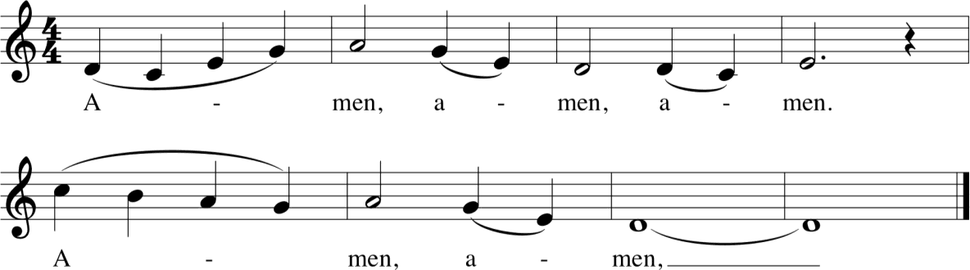

The Lord’s Prayer
Bishop And now, as our Savior Christ has taught us, we are bold to say,
People Our Father in heaven, hallowed be your name, your kingdom come, your will be done, on earth as in heaven. Give us today our daily bread. Forgive us our sins as we forgive those who sin against us. Lead us not into temptation but deliver us from evil. For the kingdom, the power, and the glory are yours now and for ever. Amen.

Pueblo Padre nuestro que estás en los cielos Santificado sea tu Nombre Venga tu reino Hágase tu voluntad En la tierra como en el cielo Danos hoy el pan de cada día y perdona nuestras ofensas, como nosotros perdonamos a los que nos ofenden. No nos dejes caer en al tentación y líbranos del mal. Porque tuyo es el reino, tuyo es el poder, y tuya es la gloria ahora y por siempre. Amén.

The Breaking of the Bread
Bishop Christ our Passover is sacrificed for us;
People Therefore let us keep the feast.

Invitation
The Bishop says
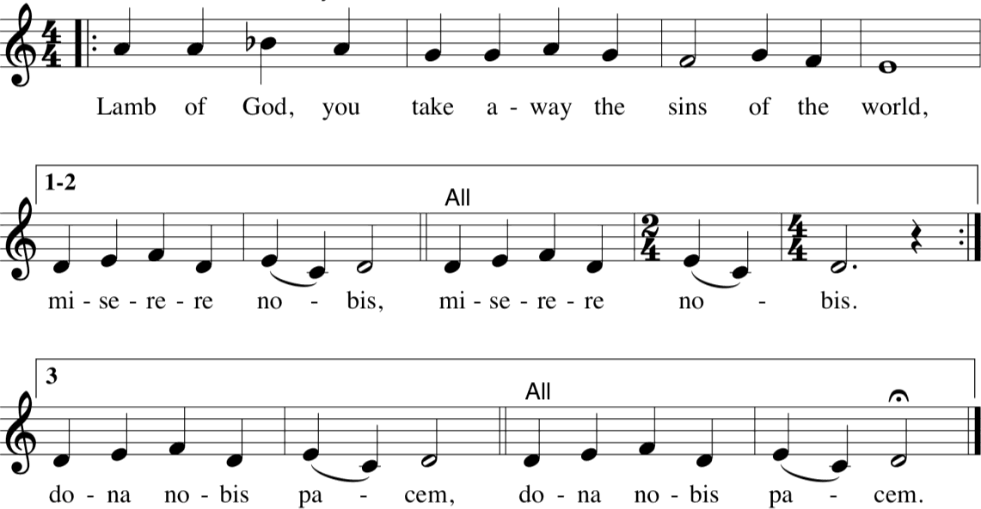
Bishop Taste and see that the Lord is good.

Spiritual Communion
Lord of the Feast, we thank you for gathering us as your people. We call to remembrance the many times we have been fed at your table and we lament our distance now. Be present Lord Jesus as you were present with your disciples, be known to us in the breaking of the bread, and may your Holy Spirit sustain us and all your Church until we can gather together again. We ask this for the sake of your love. Amen.

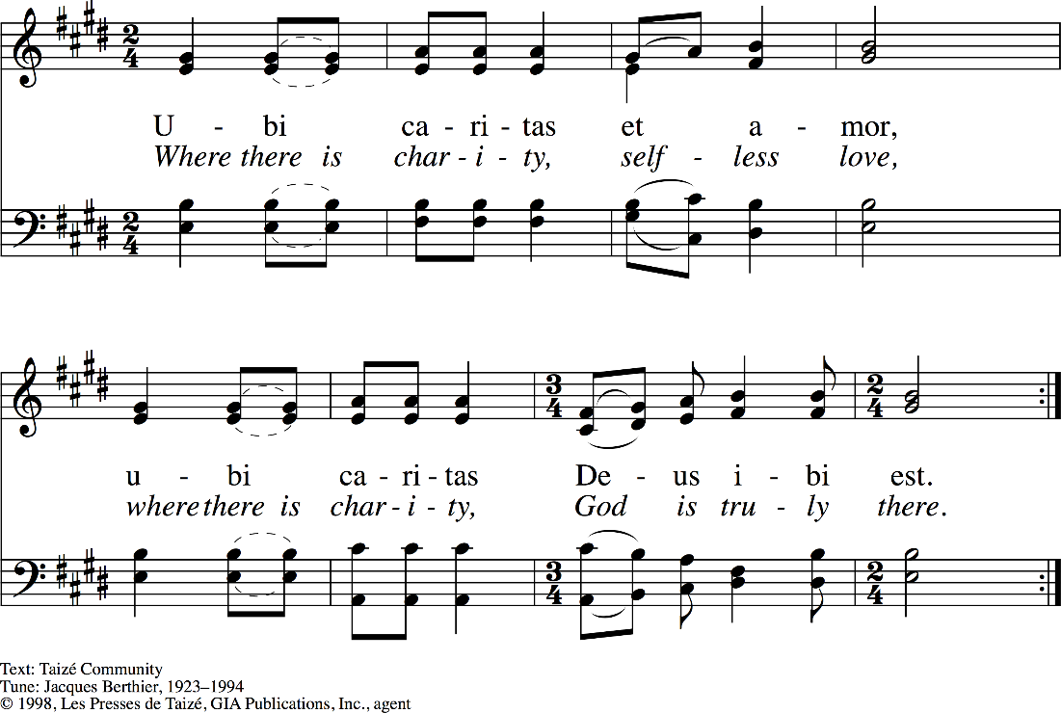
Communion Music

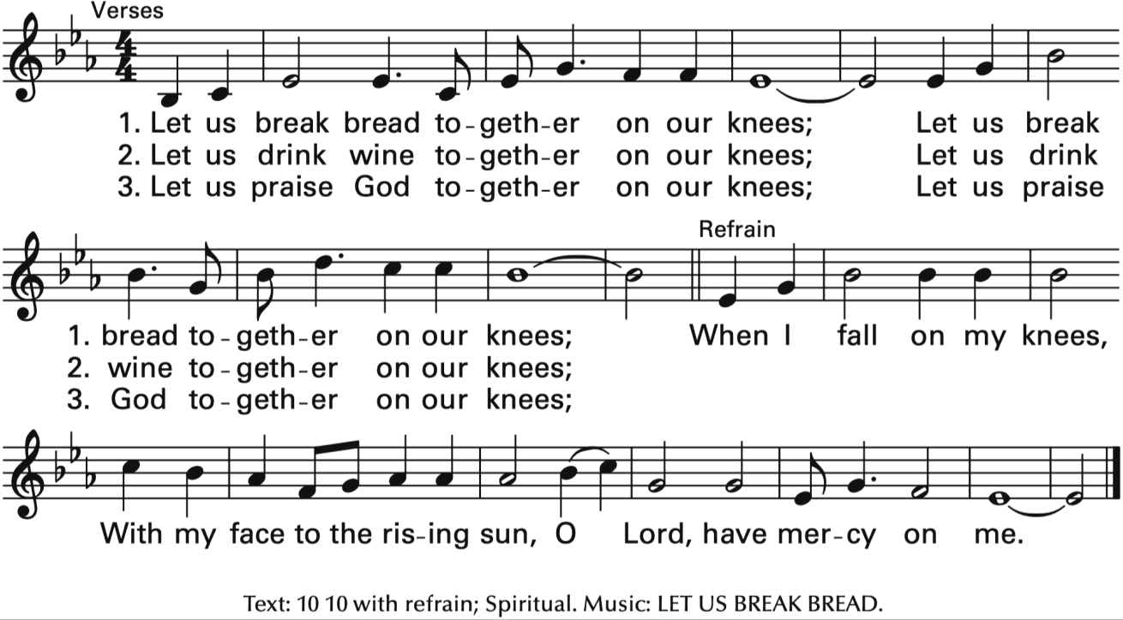
Communion Music

Post-Communion Prayer
After Communion, the Bishop says
Bishop God is with you. Obispo El Señor sea con ustedes.
People And also with you. Pueblo Y con tu espíritu.
Bishop Let us pray. Obispo Oremos
Bishop & People
Let us pray. O God, we give you thanks that you have set before us this feast, the body and blood of your Son. By your Spirit strengthen us to serve all in need and to give ourselves away as bread for the hungry, through Jesus Christ our Lord. Amen.

The Blessing of Oils
Immediately after the post-communion prayer, the prepared oils are brought to the altar. Facing the people, the Bishop addresses the people with these words

Holy Chrism (Sanctum chrisma)
Bishop Dear Friends in Christ: In the beginning, the Spirit of God hovered over the creation; and, throughout history, God, by the gift of the Holy Spirit, empowered his people to serve him. As a sign of that gift, the priests and kings of Israel were anointed with oil; and our Lord Jesus was himself anointed with the Holy
Spirit at his Baptism as the Christ, God’s own Messiah. At baptism, Christians are likewise anointed by that same Spirit to empower them for God’s service. Let us now consecrate this oil to be the sign of that anointing.

The Bishop then places a hand on the vessel filled with Chrism oil and prays
Eternal God, whose blessed Son was anointed by the Holy Spirit to be the Savior and servant of all, we pray you to bless + and consecrate this oil, that those who with it are sealed may share in the royal priesthood of Jesus Christ; who lives and reigns with you and the Holy Spirit, for ever and ever. Amen.

Oil for the Anointing of the Sick (Oleum infirmorum) The Bishop says
From time immemorial, the people of God ministered to the sick of their community with prayers, with
the laying on of hands, and by anointing them with oil. Let us now set apart this oil to be the sacramental sign of this anointing for healing and blessing.

The Bishop then places a hand on the vessel filled with Oil for the Anointing of the Sick and prays
Lord God, loving Creator, you bring healing to the sick through your Son, Jesus Christ. Hear us as we pray
to you in faith, and send your Holy Spirit, our Helper, and Friend, upon this oil, which nature has provided to serve the needs of men. May your blessing come upon all who are anointed with this oil, that they may be freed from pain and illness and made whole again in body, mind, and soul. Eternal God, may this oil be blessed + for your Church’s use, in the name of our Lord Jesus Christ, who lives and reigns with you for ever and ever. Amen.

Oil for the Anointing of Catechumens (Oleum catechumenorum) The Bishop says
In the ancient Church, those who were preparing for baptism were admitted by liturgical acts into a period of
study, reflection, encouragement, instruction in the history of salvation as revealed in the Holy Scriptures of the Old and New Testaments, and immersion in the life of prayer and the practice of Christian action. Let us now set apart this oil to be a sign of blessing and entry.

The Bishop then places a hand on the vessel filled with Oil for the Anointing of Catechumens and prays
Lord God, protector of all who believe in you, bless + this oil and give wisdom and strength to all who are anointed with it in preparation for their baptism. Bring them to a deeper understanding of the gospel, help them to accept the challenge of Christian living, and lead them to the joy of new birth in the family of your
Church. We ask this through Christ our Lord. Amen.

The Dismissal
A Deacon dismisses the people
Deacon Our worship is ended. Our service in the world now begins. Let us go forth into the world, rejoicing in the power of the Spirit.
People Thanks be to God.

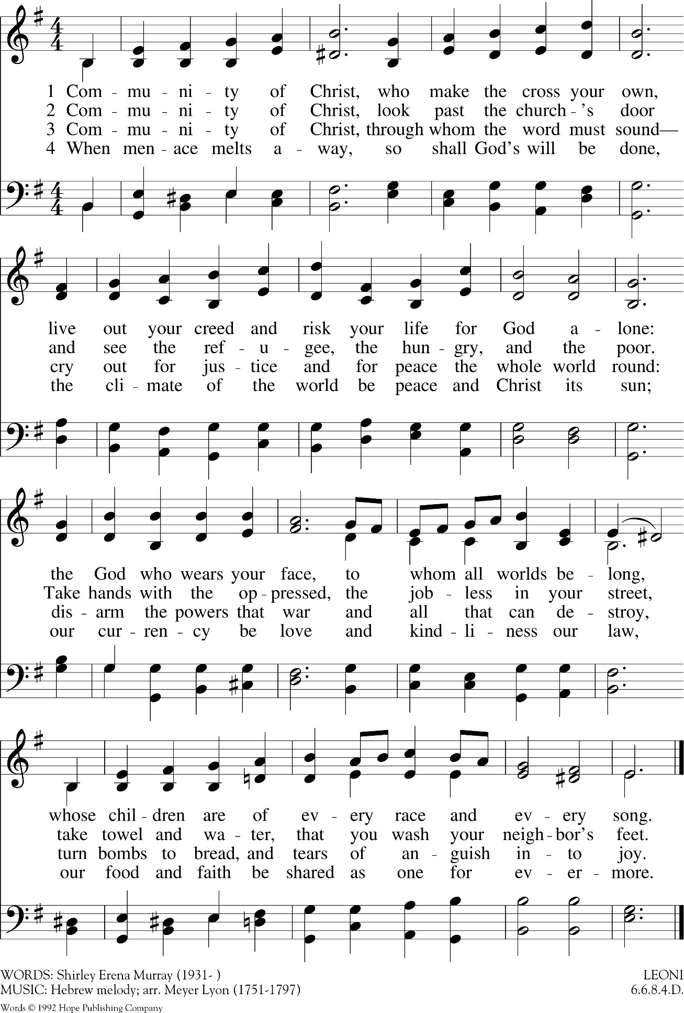
CLOSING HYMN: “COMMUNITY OF CHRIST”

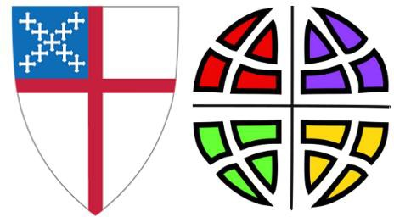

We give thanks for the gift of today and the gathering of
Lutherans and Episcopalians as live more fully in our call to Common Mission.
We are grounded in Baptism and strengthened for ministry in the world from the table of Christ.
Together we are called to transform the world in love.
May we go forth from this place renewed in our commitment to build Beloved Community, to seek justice, and to pursue the things that make for peace.

Special Thanks to
The Central States Synod of the Evangelical Lutheran Church in America
Bishop Susan Candea & Synod Staff

The Episcopal Diocese of Missouri
Bishop Deon K. Johnson & Diocesan Staff

The Clergy & People of St. Timothy’s Episcopal Church especially:
The Rev. Liz Mead & The Rev. Camie Dewey The Live-stream & technical team
The hospitality team The Musicians

