Opening Hymn
The clergy and people process into the worship space. The newly selected clergy remains outside the main entrance door. The Bishop, or representative, greets the people.

Greeting
Dear people of God, in Holy Baptism we are buried and raised with Christ to new life and empowered by the Holy Spirit to proclaim, far and near, the Good News of Salvation. We come bearing a variety of gifts, talents, and skills to proclaim God’s love, to abide in hope, and to be renewed in faith. For generations countless women and men, both lay and ordained have been bearers of the Good News of Jesus Christ in this place.

We come today, not to make new but to renew the ministry that this community of love proclaims. We give thanks for those who have brought us to this day and we lay the foundation for those who will come after. We gather with our spiritual ancestors, who crowd the air about us, to continue the legacy of hope and expectation for which this community is named. We gather to offer holy hospitality as Christ makes all things new. As we celebrate the renewal of ministry and emergence of new relationships, let us commit ourselves to walking in the way of the Risen One. Therefore, let us dedicate ourselves once more to being prophets of hope, and bearers of love as we follow Jesus Christ our Savior.

Acclamation & Collect
Presider Blessed be the One, Holy and Living God. People Glory to God, for ever and ever. Amen. Presider There is one Body and one Spirit;
People There is one hope in God’s call to us; Presider One Lord, one Faith, one Baptism; People One God and Creator of all.
Presider God is with you.
People And also with you.
Presider Let us pray:
Silence is kept for a time.

Presider O God of unchangeable power and eternal light: Look favorably on your whole Church, that wonderful and sacred mystery; by the effectual working of your providence, carry out in tranquility the plan of salvation; let the whole world see and know that things which were cast down are being raised up, and things which had grown old are being made new, and that all things are being brought to their perfection by him through whom all things were made, your Son Jesus Christ our Lord; who lives and reigns with you, in the unity of the Holy Spirit, one God, for ever and ever. Amen.

The Bishop, Wardens and other leaders of the congregation make their way to main doors of the worship space. Instrumental music may be played or a hymn may be sung.

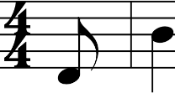Adam M. L. Tice
'd
Leader

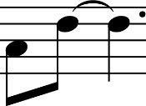
D Ir J J d
FOREST BLUE
Andrew Donaldson
Al/--3--i
I J J J

- Re - joice, re - Joice,
- In mar - ket square
,.
3 7
J
come sing with and cit - y

Leader
..
j
me: street
"this is the we seek the
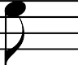
,, t·

r r Ir-
Jl Ir CJ

house of God!" The tern - ple gates
peace of God. Be - fore the rul
swing er's

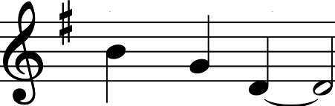
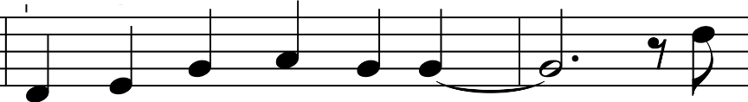
,----3---, All 3---, ,-----3--, Leader

wide and free­ judg-ment seat
this is the house of God! we seek the peace of God.
For In

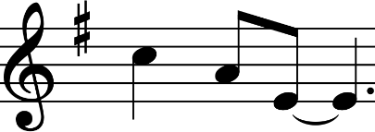
ev - 'ry tribe joy - Jul song
,.
.-----3---,
All 3 ,
_{D} Ir i J j IJ J J
--
and ev - 'ry race this IS the
and whis - pered prayer we seek the

Leader

J r r Ir-
house of God!
peace of God.
'- D Ir D I
God calls us to this
God's cit - y can be

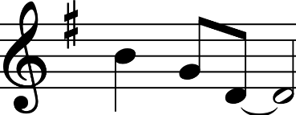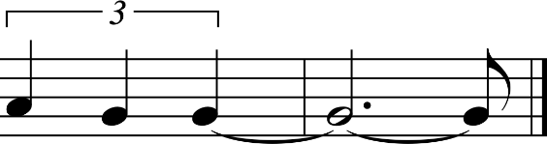
IJ J J

ho - ly place­ an - y-where
this 1s the house of we seek the peace of
God!
God.

Text Copyright © 2011 by GIA Publications, Inc. • All Rights Reserved Music Copyright © 2011 by Andrew Donaldson

Welcome
The community is seated.

Greeter Who are you and why have you come?
Priest I am NN, a servant and follower of Jesus Christ, and I come as one seeking the grace of God, the
prayers of God’s holy people and to be a companion with fellow followers of Christ as we embark on a new journey.

Warden NN we welcome you to this place. How do you come among us and with what confidence?
Priest I come knowing nothing except Jesus Christ, crucified and risen. I come as a pilgrim to walk in love with the people of God here at [Congregation’s Name] and to be together strengthened for the journey ahead.

Bishop People of , you have reflected on your ministry and discerned your choice for a new Rector.

Wardens We have chosen and called N.N. to be our Rector, and she/he has accepted.

Bishop I commend your choice and affirm this call

The Letter of Institution
The Letter of Institution (BCP, p. 557) is read.

All standing
Bishop Are you, the people of , ready to continue in your ministry, with N. as your priest?
People We are.

Deacon Let us then humble ourselves before God and together seek God’s mercy and strength. Let us pray.
Silence is kept for a time.

Priest Lord God, you have built your Church on the foundation of the apostles and prophets and you sent your Holy Spirit to guide and empower your church for the work of ministry; it is through that guidance alone that we can make right choices to carry on the work of ministry; you alone know the thoughts of human hearts; you alone can enable us to discern the gifts you have given.

Warden Help us now to open ourselves to the presence of your Spirit; be with us in the quiet and peace of this time of prayer and listening; make us instruments of your will for your Church, that we may be prepared to serve your people and glorify your name.

Leader You are great, O God, and worthy of highest praise; you stir in us the joy of praising you, since you have made us for yourself and our hearts are restless until they find rest in you.

Deacon One thing have I asked of the Lord; one thing I seek; that I may dwell in the house of the Lord all the days of my life; to behold the fair beauty of the lord and to see the Holy One in the temple. For God alone my soul in silence waits; from God comes my salvation. Psalm 27:5-6, 62:1

Silence is kept for a time.

Prayer
The newly selected priest, standing inside the doorway inclines or kneels devoutly praying.
Priest Teach us, O God, to view our life here on earth as a pilgrim’s path to heaven, and give us grace to tread it courageously in the company of your faithful people.

People Help us to set our affections on things above, not on the passing vanities of this world, and grant that as we journey on in the way of holiness we may bear a good witness to our Lord, and serve all who need our help along the way, for the glory of your name. Amen

Priest Bless to me, O God, the earth beneath my feet. Bless to me, O God, the path whereon I go. Bless to me, O God, the people whom I meet, today, tonight and tomorrow. Amen

A hymn or suitable music may be played as the community gathers by the font.

Giving of Baptismal Water
Bishop N.; people of : in Holy Baptism we received full adoption through God’s grace and full empowerment for ministry through the Holy Spirit. Will you work together as partners in the mission of the Church, to reconcile all people to God through Christ?
People We will, with God’s help.

The Bishop then addresses the priest.
Bishop N., take this water, a symbol of new birth, new life, new hope, and help me baptize in obedience to our Lord.
Priest Amen

Thanksgiving Over Water
Presider God is with you.
People And also with you.
Presider Let us give thanks to the Lord our God.

People It is right to give our thanks and praise.
Presider We thank you God for your love in all creation, especially for your gift of water to sustain, refresh and cleanse all life. We give you thanks for the gift of baptism. In this water we were buried with Christ in his death; from this water we were raised to share in the resurrection; through this water we were reborn of the Holy Spirit. We thank you that through the waters of baptism you cleanse us, renew us by your Spirit and raise us to new life. In the new covenant we are made members of your Church and share in your eternal kingdom. We pray that all who have passed through the waters of baptism may continue for ever in the risen life of Christ.

People Pour out your Holy Spirit, that as we died and rose again in the water of baptism, we may now preach good news to the poor, proclaim release to the captives, and set at liberty those who are oppressed.
Presider Through Christ, in the unity of the Holy Spirit, all praise and thanks be yours, Redeemer God, now and for ever. Amen.

Renewal of Baptismal Vows
Presider Dear friends in Christ, each of us has made public profession of our faith, therefore let us renew the call to follow Christ by serving the world in his name. Will you uphold the covenant God made with you in holy baptism: To continue the apostle’s teaching and fellowship, the breaking of bread and prayers; to resist evil and seek repentance and forgiveness; to proclaim in word and deed the Good

News; to seek and serve Christ by loving your neighbor and yourself; and to strive for justice and peace in all the earth?
People I will, God being my helper and guide.

Sprinkling Rite
Presider May this water be a reminder of the outpouring of the Holy Spirit which enlightens us with Holy Wisdom: that it may renew in us our call to ministry and strengthen us for loving service, that we may proclaim and live the Good News of Christ.
The congregation is then sprinkled as a reminder of their baptism or may be invited to touch the water in the font.

Hymn or Instrumental Music

The Liturgy continues with the readings.

Following the Sermon all standing.

The Creed

Deacon Let us stand and affirm our faith. Do you reaffirm your renunciation of evil and renew your commitment to Jesus Christ?
People I do.

Deacon Do you believe in God the Father?

People I believe in God, the Father almighty, creator of heaven and earth.

Deacon Do you believe in Jesus Christ, the Son of God?

People I believe in Jesus Christ, his only Son, our Lord. He was conceived by the power of the Holy Spirit and born of the Virgin Mary. He suffered under Pontius Pilate, was crucified, died, and was buried. He descended to the dead. On the third day he rose again. He ascended into heaven, and is seated at the right hand of the Father. He will come again to judge the living and the dead.

Deacon Do you believe in God the Holy Spirit?
People I believe in the Holy Spirit, the holy catholic Church, the communion of saints, the forgiveness of sins, the resurrection of the body, and the life everlasting. Amen.

The Prayers
A symbol of prayer (e.g., a book of prayers, the list of intercessions, an icon) is brought forward by Intercessor(s) from the congregation.

Leader N., with this we offer our prayers, intercessions and thanksgivings to God.
Rector Amen. In the Spirit of God, who searches the heart and knows our deepest needs, let us pray for the Church, the world, and all who yearn for Christ’s healing.

The Prayers of the People follows.

The Presentation of Gifts
A symbol of healing is now presented with these words.

Leader N., with prayer, companionship and laying-on of hands we bring the reconciling presence of Christ to those who seek healing. Join us in this ministry by calling us to repentance, and assuring us of God’s forgiveness and love.
Rector Amen. Live without fear: your Creator has made you holy, loves you eternally, and reconciles you to one another.

Other gifts may be presented including a stole, keys, and canons.
Leader Meghan, accept this Bible, and be among us as we proclaim the Sacred Stories.
Rector Amen. Together let meditate on God’s work in the world.

Leader N., receive this stole (and chasuble), and be among us as a pastor and priest.
Rector Amen. Together let us proclaim the Good News of salvation.

Leader N., receive this book/icon/symbol, and be among us as one rooted and grounded in prayer.
Rector Amen. Our lives will be living prayers to all in need.

Leader N., receive these keys, and let the doors of this place be open to all people.
Rector Amen. My house shall be called a house of prayer for all people.

Leader N., obey these Canons, and be among us to share in the councils of this diocese.
Rector Amen. We will seek the presence of the Holy Spirit in all that we do.

The bread and wine are now presented with these words.
Leader N., when we share the bread and the cup, we proclaim the Lord’s death until he comes. Join us at God’s table to offer and bless our gifts of bread and wine.
Rector Amen. Together, let us keep the feast.

The Bishop now presents a gift to the new Rector concluding with these words.
Bishop We offer thanksgiving to God for the ministries represented by these symbols, and ask God’s grace to live ever more fully into the commitments we have made in Baptism.
People Amen.

The peace is then exchanged. The Great Thanksgiving & the distribution of communion follows.

Postcommunion Prayer
Rector God is with you.
People And also with you.
Rector Let us pray.

People Loving God, we give you thanks for restoring us in your image and nourishing us with spiritual food in the Sacrament of Christ’s Body and Blood. Now send us forth a people, forgiven, healed, renewed; that we may proclaim your love to the world and continue in the risen life of Christ our Savior. Amen.

Bishop We have celebrated this new pastoral relationship in the great prayer of the Church. N., I commend to your love and care the people of . My brothers and sisters in Christ, I commend to your love and care your new Rector, colleague and friend, N.

The bishop, or the Rector, may bless the assembly. The final hymn and dismissal follows.

