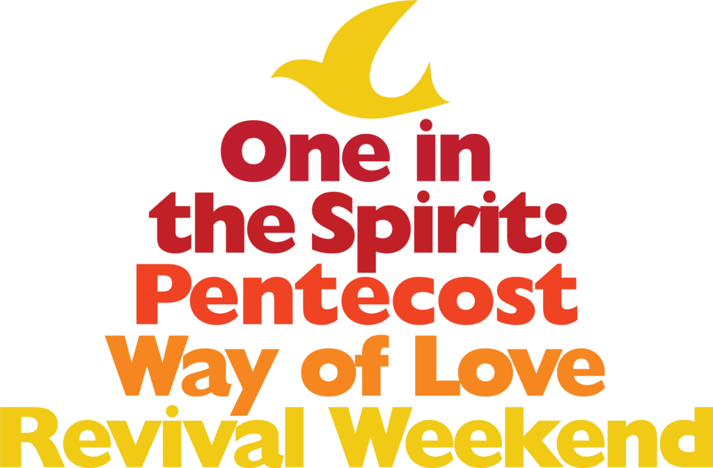

Revival Service Leaflet May 23, 2021

Welcome to One in Spirit: A Pentecost Revival Service

Bienvenidos a Uno en el Espíritu:
un oficio de avivamiento de Pentecostés

The Episcopal Church greets Pentecost with One in the Spirit, a Way of Love Revival Weekend designed to fan the flames of hope, celebrate difference, honor creation, foster beloved community, and send people toward Jesus’ Way of Love.  Worship lies at the heart of the life of faith. Through encountering God in worship—online and in- person—we are formed and transformed as the people of God. We come together today to pray for renewal, to give testimony, and to preach the Good News of God in Jesus Christ. Celebrating the life of the church and the renewal of our life together makes a difference in the world and in our lives.  As we live and love our way through the coming days and months, we are especially mindful of how our world continues to be shaped by a global pandemic and our continued struggle against white supremacy and hate. We know there is no better way to celebrate the One who makes us one than to sing and share and pray alongside each other.  It is necessary to the nourishment of our souls and the worship of God to:  - Renew our commitment to one another and to the life of the Church  - Testify to God’s faithfulness to us through all times and in all places  - Preach the Good News of God in Christ to all the ends of the Earth.  It is our great pleasure and deep joy to worship with you today. In song, story, prayer, and scripture, we hope you will hear God calling you to love beyond what you can ask or imagine. | La Iglesia Episcopal saluda a Pentecostés con Uno en el Espíritu, un fin de semana de avivamiento del Camino del Amor diseñado para avivar la llama de la esperanza, celebrar la diferencia, honrar la creación, fomentar la comunidad amada y enviar a al pueblo hacia el Camino del Amor de Jesús.  El culto está en el tuétano de la vida de la fe. Al encontrarnos con Dios en el culto —de manera virtual y presencial—somos formados y transformados como pueblo de Dios. Nos reunimos hoy para orar por la renovación, dar testimonio y predicar la Buena Nueva de Dios en Jesucristo. Celebrar la vida de la Iglesia y la renovación de nuestra vida juntos marca una diferencia en el mundo y en nuestras vidas.  Según vivimos y amamos en nuestro camino durante los próximos días y meses, somos especialmente conscientes de cómo nuestro mundo sigue siendo moldeado por una pandemia global y nuestra lucha continua contra la supremacía blanca y el odio. Sabemos que no hay mejor manera de celebrar a Aquel que nos hace uno que cantar, compartir y orar juntos.  Es necesario para la alimentación de nuestras almas y el culto a Dios:  - Renovar nuestro compromiso los unos con los otros y con la vida de la Iglesia.  - Testificar de la fidelidad de Dios para con nosotros en todo momento y en todo lugar.  - Predicar la Buena Nueva de Dios en Cristo a todos los confines de la Tierra.  Es nuestro gran placer y júbilo intenso adorar con ustedes hoy. Mediante cánticos, historias, oraciones y lecturas bíblicas, esperamos que escuchen a Dios  llamándoles a amar más allá de lo que puedan pedir o imaginar.

Pre-Service Music and Dove Release Música y liberación de palomas antes de comenzar el oficio
Washington National Cathedral Catedral Nacional de Washington

Precious Lord, Take My Hand Precioso
Señor
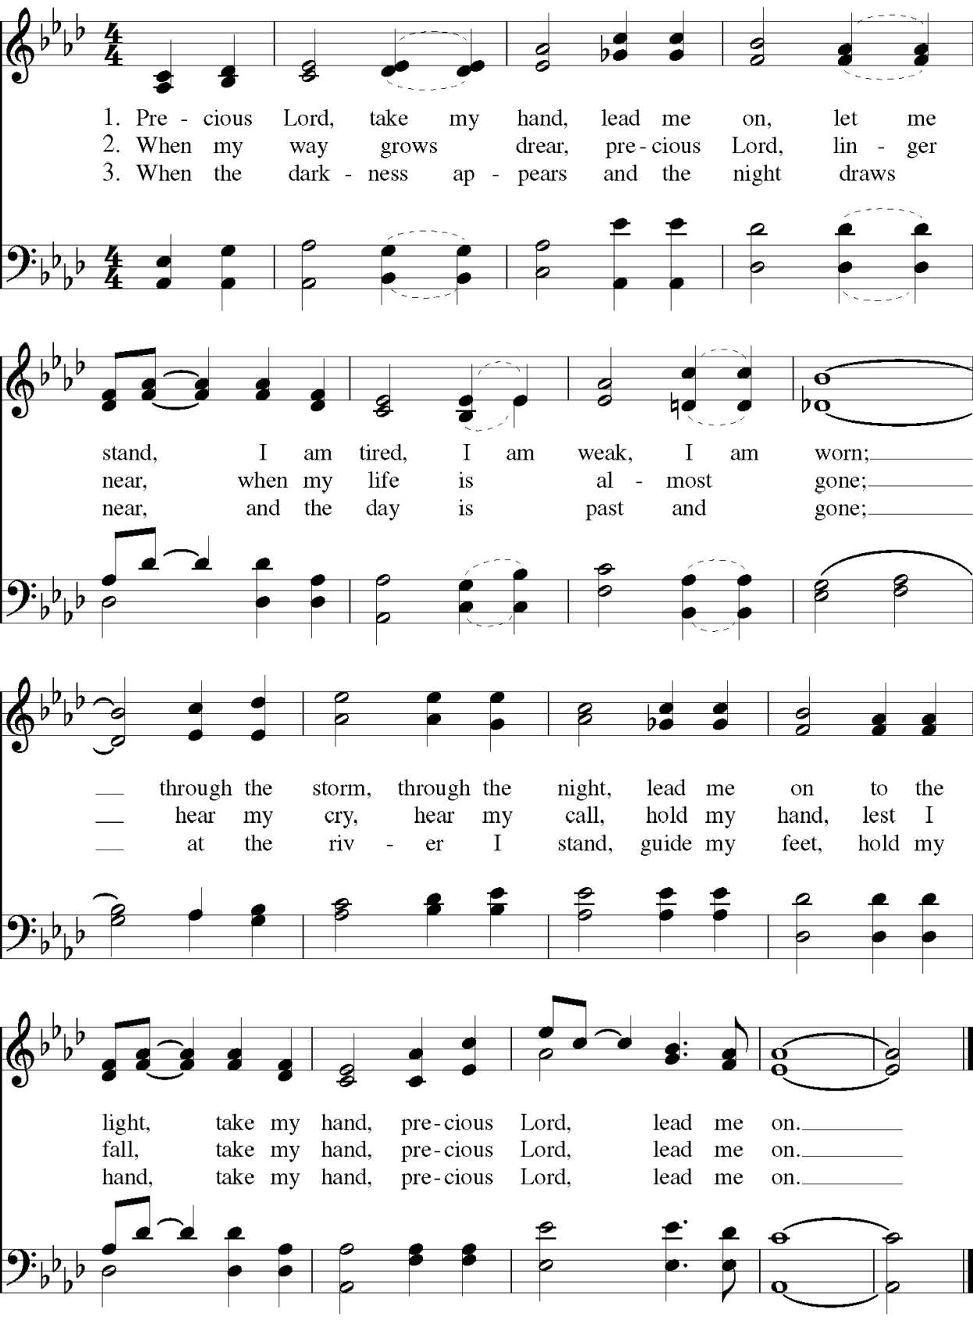

Opening Hymn Himno de Entrada

Hail Thee, Festival Day
The Hymnal 1982 #225
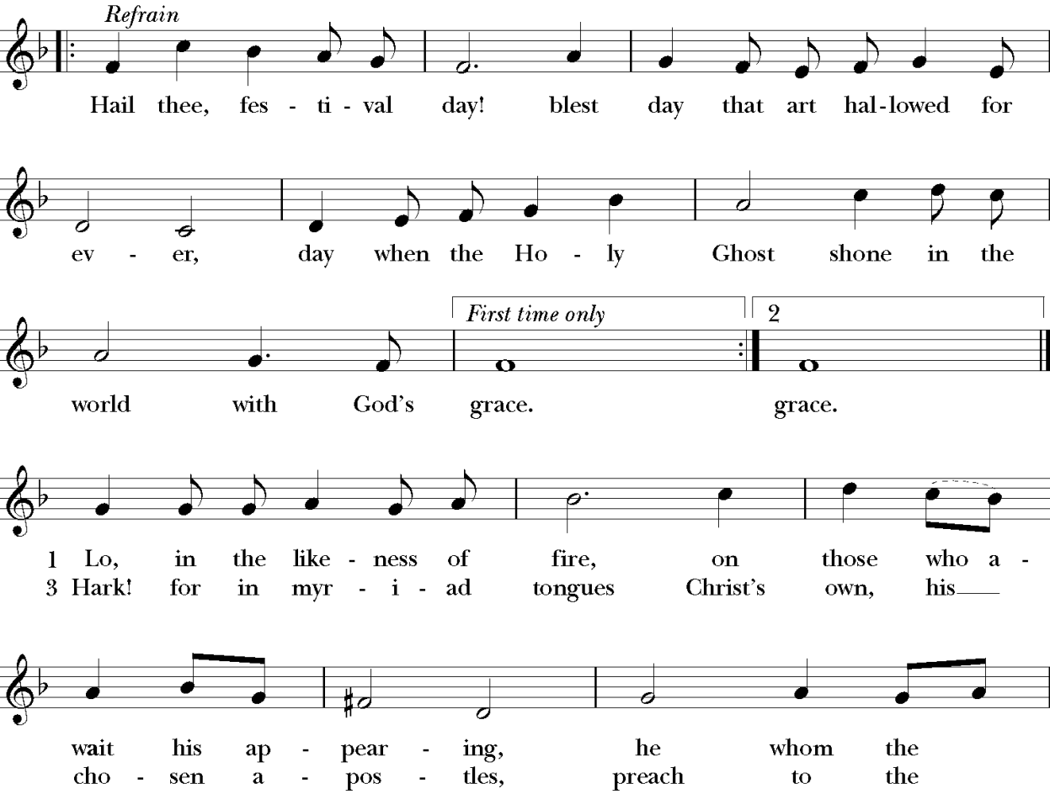
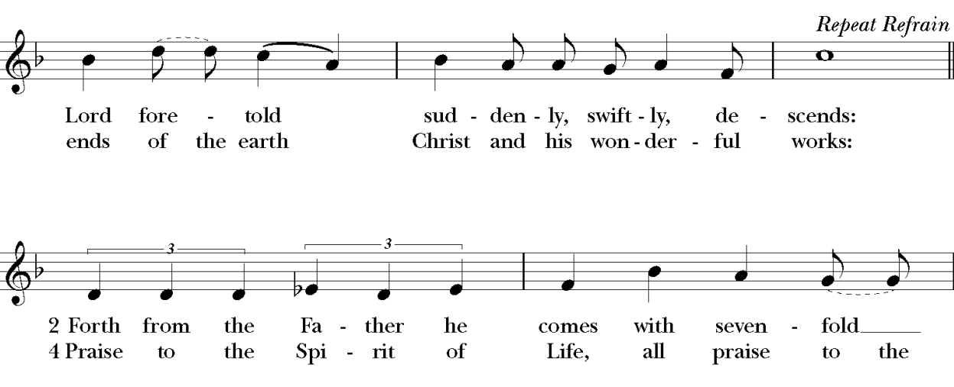

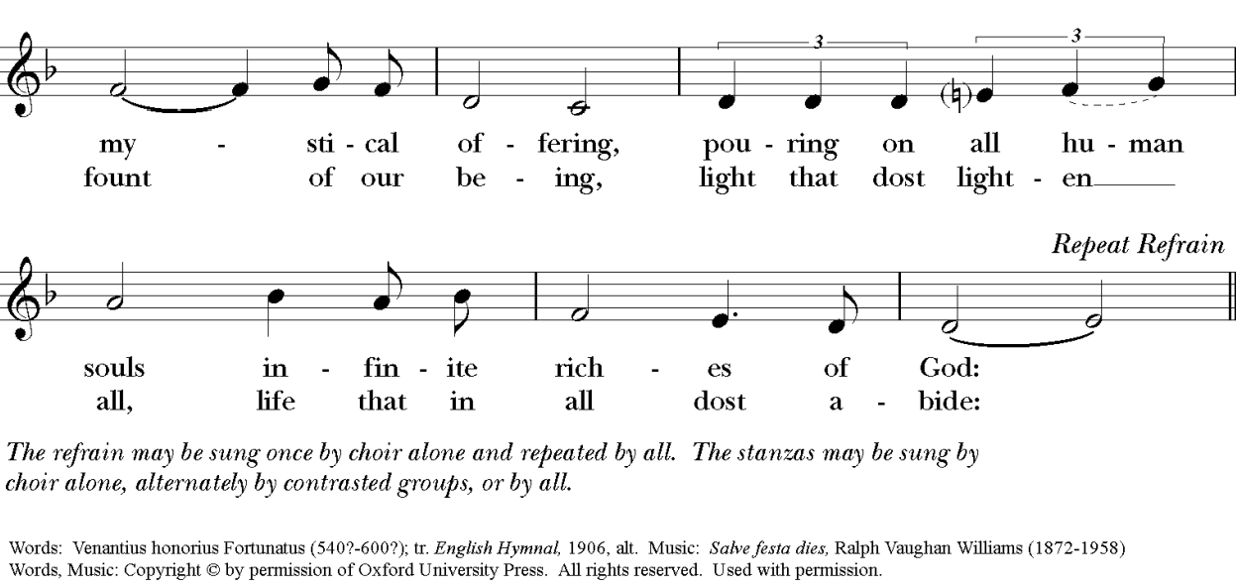

Welcome to Worship  Opening Prayer  Bishop Deon Johnson, Episcopal Diocese of Missouri  Let us pray.  God of all power and love, we give thanks to you for your unfailing presence and the hope you provide in times of uncertainty and loss. Send your Holy Spirit to rekindle in us your holy fire. Revive us to live as Christ's body in the world, a people who pray, worship, learn, break bread, share life, heal neighbors, bear good news, seek justice, rest, and grow in the Spirit. Wherever and however we gather, unite us in common prayer and send us in common mission that we, and the whole creation, might be restored and renewed through Jesus Christ, our Lord.  Amen | Bienvenidos al culto  Oración de apertura Obispo Deon Johnson, Diócesis de Misurí  Oremos.  Dios de todo poder y amor, te damos gracias por tu presencia inquebrantable y la esperanza que brindas en tiempos de incertidumbre y pérdida. Envía tu Espíritu Santo para reavivar en nosotros tu fuego sagrado.  Avívanos para vivir como el cuerpo de Cristo en el mundo, un pueblo que ora, adora, aprende, parte el pan, comparte la vida, restaura a sus prójimos, da buenas nuevas, busca la descansa y crece en el espíritu. Dondequiera y de cualquier manera que nos reunamos, únenos en oración comunitaria y envíenos en comunitaria para que nosotros, y toda la creación, seamos restaurados y renovados por Jesucristo, nuestro Señor.  Amén.

On Renewal

We speak aloud and proclaim a renewal of our faith, remembering the words spoken by the prophet Ezekiel.

The reading is offered in Navajo, by the Rev. Paula Henson

La renovación

Hablamos alta y proclamamos una renovación de nuestra fe, recordando las palabras dichas por el profeta Ezequiel.

La lectura se ofrece en Navjo, por Rva. Paula Henson.

Ezekiel 37:1-14. (NRSV)
The hand of the LORD came upon me, and he brought me out by the spirit of the LORD and set me down in the middle of a valley; it was full of bones. He led me all around them; there were very many lying in the valley, and they were very dry. He said to me, “Mortal, can these bones live?” I answered, “O Lord GOD, you
know.” Then he said to me, “Prophesy to these bones, and say to them: O dry bones, hear the word of the LORD. Thus says the Lord GOD to these bones: I will cause breath to enter you, and you shall live. I will lay sinews on you, and will cause flesh to come upon you, and cover you with skin, and put breath in you, and you shall live; and you shall know that I am the LORD.”

So I prophesied as I had been commanded; and as I prophesied, suddenly there was a noise, a rattling, and the bones came together, bone to its bone. I looked, and there were sinews on them, and flesh had come upon them, and skin had covered them; but there was no breath in them. Then he said to me, “Prophesy to the breath, prophesy, mortal, and say to the breath: Thus says the Lord GOD: Come from the four winds, O breath, and breathe upon these slain, that they may live.” I prophesied as he commanded me, and the breath came into them, and they lived, and stood on their feet, a vast multitude.

Then he said to me, “Mortal, these bones are the whole house of Israel. They say, ‘Our bones are dried up, and our hope is lost; we are cut off completely.’ Therefore prophesy, and say to them, Thus says the Lord GOD: I am going to open your graves, and bring you up from your graves, O my people; and I will bring you back to the land of Israel. And you shall know that I am the LORD, when I open your graves, and bring you up from your graves, O my people. I will put my spirit within you, and you shall live, and I will place you on your own soil; then you shall know that I, the LORD, have spoken and will act, says the LORD.”
Ezequiel 37:1-14 (NVI)
La mano del SEÑOR vino sobre mí, y su Espíritu me llevó y me colocó en medio de un valle que estaba lleno de huesos. Me hizo pasearme entre ellos, y pude abras que había muchísimos huesos en el valle, huesos que estaban completamente secos. Y me dijo: «Hijo de hombre, ¿podrán revivir estos huesos?» Y yo le contesté: «SEÑOR omnipotente, tú lo sabes». Entonces me dijo: «Profetiza sobre estos huesos, y diles: “¡Huesos secos, escuchen la palabra del SEÑOR! Así dice el SEÑOR omnipotente a estos huesos: ‘Yo les 6abr aliento de vida, y ustedes volverán a vivir. Les pondré abras, abr que les salga carne, y los cubriré de piel; les abr aliento de vida, y así revivirán. Entonces sabrán que yo soy el SEÑOR’ ”».

Tal y como el SEÑOR me lo había mandado, profeticé. Y mientras profetizaba, se escuchó un ruido que sacudió la tierra, y los huesos comenzaron a unirse entre sí. Yo me fijé, y vi que en ellos aparecían abras, y les salía carne y se recubrían de piel, ¡pero no tenían vida! Entonces el SEÑOR me dijo: «Profetiza, hijo de hombre; conjura al aliento de vida y dile: “Esto ordena el SEÑOR omnipotente: ‘Ven de los cuatro vientos, y dales vida a estos huesos abras para que revivan’ ”».
Yo profeticé, tal como el SEÑOR me lo había ordenado, y el aliento de vida entró en ellos; entonces los huesos revivieron y se pusieron de pie. ¡Era un ejército numeroso!

Luego me dijo: «Hijo de hombre, estos huesos son el pueblo de Israel. Ellos andan diciendo: “Nuestros huesos se han secado. Ya no abras esperanza.
¡Estamos perdidos!” Por eso, profetiza y adviérteles que así dice el SEÑOR omnipotente: “Pueblo mío, abriré tus tumbas y te sacaré de ellas, y te abr regresar a la tierra de Israel. Y, cuando haya abierto tus tumbas y te haya sacado de allí, entonces, pueblo mío, abras que yo soy el SEÑOR. Pondré en ti mi aliento de vida, y volverás a vivir. Y te estableceré en tu propia tierra. Entonces abras que yo, el SEÑOR, lo he dicho, y lo cumpliré. Lo afirma el SEÑOR”».

A Testimony on Renewal  Ms. Ellie Singer  St. Mark’s, Houston, Texas | Un testimonio de renovación  Sra. Ellie Singer  San Marcos, Houston, Texas

Community Reflection & Prayer  Where in your life do you need resurrection?  Holy Spirit, help us to feel your power and embrace your invitation to new life. | Oración y Reflexión comunitaria  ¿En qué parte de tu vida necesitas la resurrección?  Espíritu Santo, ayúdanos a sentir tu poder y a aceptar tu invitación a una nueva vida.

On Creation  An Offering of Psalm 104:25-35,37  St. Mark’s Cathedral, Seattle, Wash.  . | La creación  Ofrenda del Salmo 104: 25-35,37  Catedral de San Marcos, Seattle, Wash.

A Testimony on Creation  The Rev. Kerri Meyer, Good Courage Farm | Un testimonio en la creación  Rda. Kerri Meyer, Good Courage Farm

Community Reflection & Prayer | Oración y Reflexión comunitaria

What Spirit blessings – big and small – are you experiencing in the midst of God’s creation?  Holy Spirit, give us eyes to see and hearts to say “yes” to your untamed and untamable goodness in the world. | ¿Qué bendiciones del Espíritu, grandes y pequeñas, experimentas en medio de la creación de Dios?  Espíritu Santo, danos ojos para ver y corazones para decir «sí» a tu indómita e irreductible bondad en el mundo.

On Good News | Las Buenas Nuevas

A Reading from Acts  The Lesson is read by Christopher Sikkema (English), Jariel Rivera (Spanish), the Venerable Paul Sneve (Lakota), the Reverend John Mayen (Dinka), Sherine Paul (Hindi), Ebinezer Ranji (Tamil), Clive Samson (Tamil), Nancy Christian (Gujarat), Shyamala Santhosh (Kannada), Radha Kishore (Telugu), the Rev. Bao Moua (Hmong)*  Acts 2:1-21 (NRSV)  When the day of Pentecost had come, they were all together in one place. And suddenly from heaven there came a sound like the rush of a violent wind, and it filled the entire house where they were sitting. Divided tongues, as of fire, appeared among them, and a tongue rested on each of them. All of them were filled with the | Lectura del Libro de los Hechos  La lección es leída por Christopher Sikkema (inglés), Jariel Rivera (español), el Ven. Paul Sneve (lakota), el Rdo. John Mayen (dinka), Sherine Paul (hindi), Ebinezer Ranji (tamil), Clive Samson (tamil) , Nancy Christian (guyaratí), Shyamala Santhosh (canarés), Radha Kishore (télugu), el Rev. Bao Moua (hmong) *  Hechos 2:1-21 (NVI)  Cuando llegó el día de Pentecostés, estaban todos juntos en el mismo lugar. De repente, vino del cielo un ruido como el de una violenta ráfaga de viento y llenó toda la casa donde estaban reunidos. Se les aparecieron entonces unas lenguas como de fuego que se repartieron y se posaron sobre cada uno de ellos.  Todos fueron llenos del Espíritu Santo y comenzaron a

Holy Spirit and began to speak in other languages, as the Spirit gave them ability.

Now there were devout Jews from every nation under heaven living in Jerusalem. And at this sound the crowd gathered and was bewildered, because each one heard them speaking in the native language of each. Amazed and astonished, they asked, “Are not all these who are speaking Galileans? And how is it that we hear, each of us, in our own native language? Parthians, Medes, Elamites, and residents of Mesopotamia, Judea and Cappadocia, Pontus and Asia, Phrygia and Pamphylia, Egypt and the parts of Libya belonging to Cyrene, and visitors from Rome, both Jews and proselytes, Cretans and Arabs—in our own languages we hear them speaking about God’s deeds of power.” All were amazed and perplexed, saying to one another, “What does this mean?” But others sneered and said, “They are filled with new wine.”

But Peter, standing with the eleven, raised his voice and addressed them, “Men of Judea and all who live in Jerusalem, let this be known to you, and listen to what I say. Indeed, these are not drunk, as you suppose, for it is only nine o’clock in the morning. No, this is what was spoken through the prophet Joel:

‘In the last days it will be, God declares, that I will pour out my Spirit upon all flesh,
and your sons and your daughters shall prophesy,
and your young men shall see visions,
and your old men shall dream dreams. Even upon my slaves, both men and women, in those days I will pour out my Spirit;
and they shall prophesy.
And I will show portents in the heaven above and signs on the earth below,
blood, and fire, and smoky mist.
The sun shall be turned to darkness and the moon to blood,
before the coming of the Lord’s great and glorious day.
Then everyone who calls on the name of the Lord shall be saved.’
hablar en diferentes lenguas, según el Espíritu les concedía expresarse.

Estaban de visita en Jerusalén judíos piadosos, procedentes de todas las naciones de la tierra. Al oír aquel bullicio, se agolparon y quedaron todos pasmados porque cada uno los escuchaba hablar en su propio idioma. Desconcertados y maravillados, decían: «¿No son galileos todos estos que están hablando? ¿Cómo es que cada uno de nosotros los oye hablar en su lengua materna? Partos, medos y elamitas; habitantes de Mesopotamia, de Judea y de Capadocia, del Ponto y de Asia, de Frigia y de Panfilia, de Egipto y de las regiones de Libia cercanas a Cirene; visitantes llegados de Roma; judíos y prosélitos; cretenses y árabes: ¡todos por igual los oímos proclamar en nuestra propia lengua las maravillas de Dios!». Desconcertados y perplejos, se preguntaban: «¿Qué quiere decir esto?» Otros se burlaban y decían: «Lo que pasa es que están borrachos».

Entonces Pedro, con los once, se puso de pie y dijo a voz en cuello: «Compatriotas judíos y todos ustedes que están en Jerusalén, déjenme explicarles lo que sucede; presten atención a lo que les voy a decir. Estos no están borrachos, como suponen ustedes. ¡Apenas son las nueve de la mañana! En realidad lo que pasa es lo que anunció el profeta Joel:

“Sucederá que en los últimos días —dice Dios—, derramaré mi Espíritu sobre todo el género humano.
Los hijos y las hijas de ustedes profetizarán, tendrán visiones los jóvenes
y sueños los ancianos.
En esos días derramaré mi Espíritu
aun sobre mis siervos y mis siervas, y profetizarán.
Arriba en el cielo y abajo en la tierra mostraré prodigios:
sangre, fuego y nubes de humo.
El sol se convertirá en tinieblas y la luna en sangre
antes que llegue el día del Señor, día grande y esplendoroso.
Y todo el que invoque el nombre del Señor será salvo”.

Sermon  Presiding Bishop Michael B. Curry | Sermón  Obispo primado Michael B. Curry

Community Reflection & Prayer  As we reopen our doors and lives, how will you renew your commitment to Jesus and his Way of Love?  Holy Spirit, inspire us to follow Jesus and to love God, our neighbors, and all of creation with joy. | Oración y Reflexión comunitaria  Al tiempo de reabrir nuestras puertas y vidas, ¿cómo renovarás tu compromiso con Jesús y su Camino de Amor?  Espíritu Santo, inspíranos a seguir a Jesús y a amar a Dios, a nuestro prójimo y a toda la creación con alegría.

Prayers of the People  Led by your friends and neighbors in the Episcopal Diocese of Missouri: The Rt. Rev. Deon Johnson, Mark Throdahl, Susan Hart, Mtipe Koganni, Magdalene Linck, Rev. Susanna Raj (Telegu), Debbie Nelson Linck  Music is provided by Bria Jones (vocals) and Jae Park (piano).  You may also use this time to offer your own prayers for renewal, creation, and good news. | Oración de los fieles  Dirigida por sus amigos y vecinos en la Diócesis de Misurí: Rvdmo. Deon Johnson, Mark Throdahl, Susan Hart, Mtipe Koganni, Magdalene Linck, Rda. Susanna Raj (telegu), Debbie Nelson Linck  Bria Jones (voz) y Jae Park (piano) proporcionan la música.  También pueden utilizar este tiempo para ofrecer sus propias oraciones de renovación, creación y buenas nuevas.

Sweet, Sweet Spirit
Lift Every Voice and Sing II

There’s a sweet, sweet Spirit in this place, And I know that it’s the Spirit of the Lord. There are sweet expressions on each face,
And I know they feel the presence of the Lord.

Sweet Holy Spirit, Sweet Heavenly Dove,
Stay right here with us, filling us with your love. And for these blessings we lift our hearts in praise; Without a doubt we’ll know that we have been revived when we shall leave this place.

There are blessings you cannot receive
Till you know Him in His fullness, and believe.
You’re the one to profit when you say,
“I am going to walk with Jesus all the way.”

Sweet Holy Spirit, Sweet Heavenly Dove,
Stay right here with us, filling us with your love. And for these blessings we lift our hearts in praise; Without a doubt we’ll know that we have been revived when we shall leave this place.

If you say He saved you from your sin, Now you’re weak, you’re bound, and cannot enter in,
you can make it right if you will yield;

You’ll enjoy the Holy Spirit that we feel.

Sweet Holy Spirit, Sweet Heavenly Dove,
Stay right here with us, filling us with your love. And for these blessings we lift our hearts in praise; Without a doubt we’ll know that we have been revived when we shall leave this place.

Blessing  Presiding Bishop Michael B. Curry | Bendición  Obispo primado Michael B. Curry

Sending Out/Music/Credits Washington National Cathedral: Reprise of Doves  Great and Mighty: A Musical Offering | Envío al mundo/ Música / Créditos Catedral Nacional de Washington: Repetición de la ceremonia de las palomas  Grande y poderoso: una ofrenda musical

A service of this magnitude could not happen without the prayers, support and talents of the following persons and organizations:

Music, Readings, and Prayers:

Washington National Cathedral
Imani-Grace Cooper, vocals Daryl L.A. Hunt, piano Marshall Keys, saxophone

Members of the Cathedral Choir Michael McCarthy, canon for music

Episcopal Diocese of Missouri
The Rt. Rev. Deon K. Johnson, bishop
The Rev. Canon Whitney Rice, canon for Evangelism & Discipleship Development
Acts Reading:
Faith Christian Church of India, Ballwin, Missouri The Episcopal Diocese of Missouri

Sherine Paul - Hindi Ebinezer Ranji - Tamil
The Rev. Clive Samson - Tamil Nancy Christian - Gujarat Shyamala Santhosh - Kannada Radha Kishore - Telugu

Prayers of the People:
The Rt. Rev. Deon K. Johnson, bishop, Episcopal Diocese of Missouri

Mark Throdahl
The Episcopal Church of St. Michael & St. George Clayton, Missouri

Susan Hart
Calvary Episcopal Church, Columbia, Missouri

Mtipe Koganni
Deaconess Anne House, St. Louis, Missouri

Magdalene Linck
The Episcopal Church of the Holy Communion, University City, Missouri
The Rev. Sujanna Raj
Faith Christian Church of India, Ballwin, Missouri St. Stephen’s Episcopal Church, Ferguson, Missouri

Debbie Nelson Linck
Christ Church Cathedral, St. Louis, Missouri

Music:
Bria Jones, vocals Jae Park, piano

The Episcopal Diocese of Pennsylvania
The Rt. Rev. Daniel Gutiérrez, bishop
The Rev. Canon Shawn Wamsley, canon to the ordinary, chief of staff

The Free Church of St. John, Philadelphia, Pennsylvania
St. Thomas, Whitemarsh, Pennsylvania Jariel Jose Rivera,
La Iglesia Episcopal de Cristo y San Ambrosio y Free Church of St. John

The Episcopal Diocese of Olympia
The Rt. Rev. Greg Rickel, bishop

The Rev. Steve Thomason
Dean, Saint Mark's Episcopal Cathedral
Greg Bloch
Director of Communications, Saint Mark's Episcopal Cathedral
The Compline Choir at Saint Mark’s Cathedral Dr. Jason Anderson, director
Joel Bevington, cantor
Video footage: Gregory Bloch, Stephanie Michael, Brandon Heiser,
David Wild, Thore Noernberg, Trizek, Igor da Bari

Saint Mark’s Cathedral Beekeeping Ministry Rob Reid, ministry leader

Canon Michael Kleinschmidt, piano and composer of reflection music

*Peter R. Hallock (1924–2014) who set the Psalm, from The Compline Psalter.

The Episcopal Diocese of South Dakota
The Venerable Paul Sneve
Archdeacon of the Episcopal Diocese of South Dakota

St. Paul’s Episcopal Church, Vermillion Calvary Episcopal Cathedral, Sioux Falls
The Rev. John Mayen, Holy Apostles, Sioux Falls

The Episcopal Church in Navajoland
The Rev. Leon Sampson The Rev. Paula Henson GJ Gordy
The Rev. Jack Chase

Testimonies:
Renewal: Ellie Singer,
St. Mark's, Houston, Episcopal Diocese of Texas

Creation: The Rev. Kerry Meyer, Good Courage Farm, Episcopal Diocese of Minnesota

The Episcopal Church:
Office of the Presiding Bishop
Presiding Bishop Michael Curry
The Rev. Canon Stephanie Spellers, canon for evangelism, reconciliation and creation care
Sharon Jones , executive coordinator to the Presiding Bishop
Sarah Alphin, associate for evangelism, reconciliation and creation care

Office of Evangelism
Jerusalem Greer, staff officer for evangelism Rachel Jones, consultant
Brian Sellers-Petersen, Good News Gardens consultant

Office of Latino/Hispanic Ministries
The Rev. Canon Anthony Guillén, director of Ethnic Ministries and missioner for Latino/Hispanic Ministries
The Rev. Samuel Borbon, associate missioner for Latino/Hispanic Ministries and program development

Office of Racial Reconciliation
The Rev. Isaiah Shaneequa Brokenleg, staff officer for racial reconciliation

Office of Communication
Geoff Smith, chief operating officer
Ana Arias, project management associate Mike Collins, manager of multimedia services
Bernice David, Communication operations manager Nancy Davidge, (retired) public affairs officer Olivia Greene, editor/producer
Christopher Sikkema, Communications project manager
Amanda Skofstad, public affairs officer
Jeremy Tackett, senior manager for creative services and digital evangelist
Lisa Webb, associate staff officer for public affairs

Permissions

Opening Prayer (“Prayer for the Power of the Spirit among the People of God”) composed in May 2020 by a team of staff members working with Episcopal Church Presiding Bishop Michael Curry and Evangelical Lutheran Church in America Presiding Bishop Liz Eaton, in response to the COVID crisis and church closings.

Old Testament reading taken from the New Revised Standard Version Bible, Copyright 1989, Division of Christian Education of the National Council of the Churches of Christ in the USA. Used by permission. All rights reserved. Spanish text of the Old Testament reading taken from La Biblia de las Americas, Copyright 1986, 1995, 1997, The Lockman Foundation. All rights reserved. Used by permission. Precious Lord, Take My Hand, Thomas A. Dorsey and George Allen (Wonder, Love, and Praise); Hail Thee, Festival Day, Ralph Vaughn Williams, The Hymnal 1982 reprinted with permission from Church Publishing Group of The Episcopal Church; Te Amo Jesus (traditional, anonymous); Great and Mighty, Jonathan Nelson and Justin Savage, used by permission.

Psalm and Lord’s Prayer taken from the Book of Common Prayer, 1979. Public domain. Spanish text of the opening prayer, psalm, and Lord’s Prayer taken from El Libro de Oración Común, Copyright 1989, The Church Pension Fund. All rights reserved. Used by permission. Holy, Holy, Holy! Text: Reginald Heber (1783-1826), alt. Music: Nicaea. John Bacchus Dykes (1823-1876). Public domain. Sweet, Sweet Spirit. Text and music: Doris Akers, Copyright 1990, Manna Music. Reprinted under One License #A-709283.

