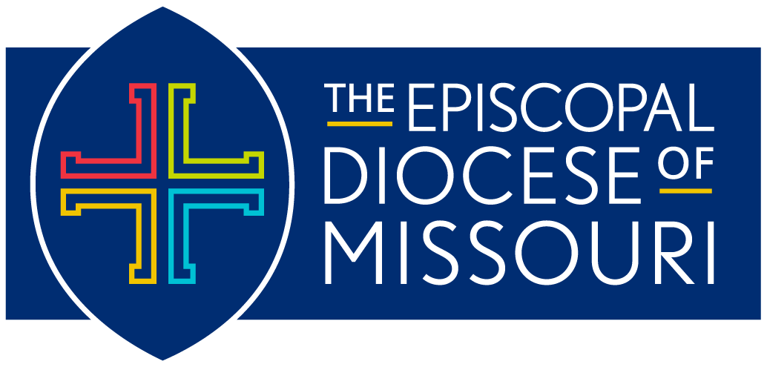

Prayers for Juneteenth
Juneteenth is the nationally celebrated commemoration of the ending of slavery in the United States. The observance began on June 19, 1865, in Galveston, Texas, as African American Emancipation Day. It has since spread across the United States and beyond.
Bishop Deon Johnson offers the prayers for congregations or individuals to use in their commemoration of Juneteenth.

The People and Clergy Pray together:
Almighty God, you rescued your people from slavery in Egypt, and throughout the ages you have never failed to hear the cries of the captives; We remember before you our sisters and brothers in Galveston, Texas who [on this day] received the glad tidings of their emancipation; Forgive us for the many grave sins that delayed that liberating word; Anoint us with your Spirit to bring good news to the poor, to proclaim release to the captives and recovery of sight to the blind, to let the oppressed go free, and to proclaim the year of your favor; through Jesus Christ our Lord, who lives and reigns with you, in the unity of the Holy Spirit, one God, for ever and ever. Amen.
OR
Holy and righteous God, you created us in your image. Grant us grace to contend fearlessly against evil and to make no peace with oppression. Help us, like those of generations before us, resist the evil of slavery and human bondage in any form and any manner of oppression. Help us to use our freedoms to bring justice among people and nations everywhere, to the glory of your Holy name through Jesus Christ our Lord. Amen.

