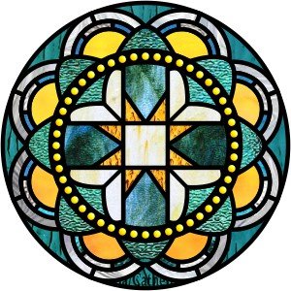

An Order for
the Celebration of
The Holy Eucharist
The Season after Pentecost


Within The Episcopal
Diocese of Missouri



Welcome! Beinvenido! Karibu!

Scattered in the world we gather together as God's people in worship. We bring the fragments of our lives to be healed and made whole in Christ as we gather in community.

Worship lies at the heart of the Christian life. It is in worship that we express our theology and define our identity. It is through encountering God within worship that we are formed and transformed as God’s people. One of the glories of the Episcopal/Anglican Church is its liturgical worship. Liturgy refers to the patterns, forms, words and actions through which public worship is conducted.

As we gather, we bring our diverse gifts: gifts of music, dance, prophecy, teaching, preaching, and friendship. We present these gifts in the form of our most precious offering to God, our very selves, that all that we do may be for God’s glory in the unity of Christ’s church.
About the Season After Pentecost

The Season after Pentecost, often called “ordinary time” or the “green season,” follows the descent of the Holy Spirit on the Church at Pentecost. During this season the usual liturgical color is green, hence being referred to as the green season. Throughout this season we hear sacred stories that highlight the manifestation of the Holy Spirit in the life of the Church along with themes of God’s creative providence.

The Season after Pentecost is the longest season of the Church year and can include up to 28 Sundays of the year. During this season we learn that Christ is about self-giving love that is only possible through authentic relationship. These are the days where we grow into who we are called to be by imitating the lived reality of Jesus.



About the
Holy Eucharist

“When God finds us, there is always a celebration. In the Eucharist, we gather to celebrate God finding us in Jesus Christ. If you’re feeling lost, when you come to receive Jesus in bread and wine, ask to be found. If you know what it is to have been found by God, when you come to receive Jesus in bread and wine, give thanks – thanks to the one who came looking for you, and found you.”
-Br. Geoffrey Tristram
Society of Saint John the Evangelist

In the Episcopal Church, the Holy Eucharist is the sacrament of Christ's body and blood, and the principal act of Christian worship. The term is from the Greek, "thanksgiving." Jesus instituted the Eucharist "on the night when he was betrayed." At the Last Supper he shared the Bread and cup of Wine at a sacred meal with his disciples. He identified the Bread with his body and the Wine with his blood of the new covenant. Jesus commanded his disciples to "do this" in remembrance of Jesus.

The Holy Eucharist, for Episcopalians, is the very Real Presence of Christ. It is his Body and Blood; the ordinary made also extraordinary. It is sacred by Jesus' own words and by the Holy Spirit.

In the Episcopal Church, we seek to adapt ancient liturgy for today. If you grew up in a less formal church, our worship may feel pretty traditional. If you grew up in a formal church, our worship may deconstruct that formality, and ask you to pray using more modern words, or sing new songs. We seek to balance tradition and culture in our worship. When we hold the tension well between the ancient and the modern, the Holy Eucharist comes alive.

Gathering Song We begin by praising God through song and prayer.

Greeting
Standing before the assembly, the Presider welcomes the community to worship.
Presider Blessed be the One, Holy and Living God.
People Glory to God, for ever and ever. Amen.

Or

Presider Blessed be our God.
People For ever and ever. Amen.

Presider Almighty God, to you all hearts are open,
People All desires known, and from whom no secrets are hid. Cleanse the thoughts of our hearts by the inspiration of your Holy Spirit, that we may perfectly love you, and worthily magnify your holy Name; through Christ our Lord. Amen.

Confession & Absolution

As we enter in to worship we ask God’s forgiveness for things done and things left undone and things done on our behalf so that we may be reconciled to each other and to God.

Presider Let us confess our sins to God..

Silence is kept for a time.

Presider God of all mercy, we confess that we have sinned against you,
opposing your will in our lives.
People We have denied your goodness in each other, in ourselves, and in the world you have created.

Presider We repent of the evil that enslaves us, the evil we have done, and the evil done on our behalf.
People Forgive, restore, and strengthen us through our Savior Jesus Christ, that we may abide in your love and serve only your will. Amen.

Presider Almighty God have mercy on you, forgive you all your sins through our Lord Jesus Christ, strengthen you in all goodness, and by the power of the Holy Spirit keep you in eternal life.
People Amen.

Song of Praise: Spoken
The Song of Praise maybe said or sung.
Presider Let us glorify the Holy One as we proclaim: Glory to God in the highest.
People For the peaceful night we praise you, for the quiet of your call, every noble tree and flower, every creature great and small.

For the breath of life, we praise you, for the mystery of our birth, for the gift of age and wisdom, for the seasons of the earth.

For the bread of life, we praise you, for the cup we share with friends, for the table heaped with bounty, for the harvest that you send. Glory to God in the highest. Amen.
© 1996, Daniel L. Schutte. Published by OCP. All rights reserved.

Song of Praise: Glory To God Based on Hymn 390 Hymnal 1982
Presider Let us glorify the Holy One as we sing.
Collect of the Day
Presider God is with you. or The Lord be with you.
People And also with you.
Presider Let us pray.
The Presider continues with the prayer appointed for the day, called the collect.
The collect is written to go along with both the season of the church year and the readings for the day. It summarizes the attributes of God as revealed in the scripture for the day.

We hear the sacred stories
We hear the stories of the experience of God from our spiritual ancestors. Reading and commenting on scripture goes back to the earliest services of Christianity. Following the pattern of Jewish synagogue worship, readings follow a set pattern for what will be read when.

The First Reading
A reading from Hebrew Scriptures.

At the end of the reading, the Reader says.
Reader Hear what the Holy Spirit is saying to God’s people.
People Thanks be to God.

The Psalm of the Day
The psalms are a part of the poetry of the Hebrew people. They express joy and sadness; loneliness and thanksgiving as part of the human longing to be united with God.

The Second Reading
A reading from the New Testament Writings.

At the end of the reading, the Reader says.
Reader Hear what the Holy Spirit is saying to the church.
People Thanks be to God.

Preparing to Hear the Gospel
We stand, as we are able, for the Gospel reading to show the particular importance we place on Jesus’ words and actions.

A hymn or the following Alleluia Tract may be sung.
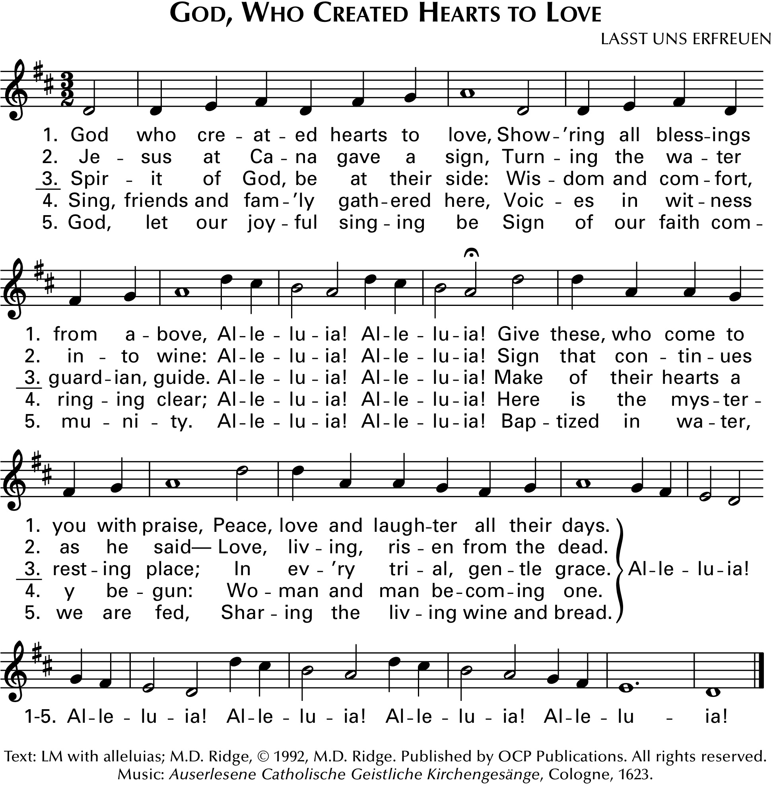
Your Word O God is life and love, shower-ing all bless - ings
from a – bove, Al -le - lu – ia! Al- le - lu –ia! You have the words to
eter - nal life, Bear –ing the bur -den of our strife Al-le – lu - ia

The Proclamation of the Gospel
Presider God is with you.
People And also with you.
Presider The Holy Gospel of our Savior Jesus Christ according to _______.
People Glory to you, O Christ.

At the end of the Gospel the Presider says
Presider The Gospel of the Lord.
People Praise to you, O Christ.

The Sermon
We remain seated for the sermon. Having someone comment on the scriptures read goes back to the earliest days of Christianity and to the Jewish Synagogue worship which preceded it.

The Affirmation of Faith
The Presider, priest or deacon, leads the assembly in an affirmation of faith. Originally the entire service was viewed as our confession of faith. But, since the Sixth Century, the church has recited either the Nicene Creed or the Apostle’s Creed at the Eucharist. The word creed comes from the Latin credo for “I believe” or “I lend my heart to.” Creeds tell a deeper “truth” that goes beyond “facts.”

The Nicene Creed, the Apostle’s Creed or An Expression of Faith may be used. In the place of a Deacon, the Presider may lead the Affirmation.

The Nicene Creed

Deacon We affirm our faith in the One, Holy and Living God.
People We believe in one God, the Father, the Almighty, maker of heaven and earth, of all that is, seen and unseen.

People We believe in one Lord, Jesus Christ, the only Son of God, eternally begotten of the Father, God from God, Light from Light, true God from true God, begotten, not made, of one Being with the Father. Through him all things were made. For us and for our salvation he came down from heaven: by the power of the Holy Spirit he became incarnate from the Virgin Mary, and was made man. For our sake he was crucified under Pontius Pilate; he suffered death and was buried. On the third day he rose again in accordance with the Scriptures; he ascended into heaven and is seated at the right hand of the Father. He will come again in glory to judge the living and the dead, and his kingdom will have no end.

People We believe in the Holy Spirit, the Lord, the giver of life, who proceeds from the Father and the Son. With the Father and the Son he is worshiped and glorified. He has spoken through the Prophets. We believe in one holy catholic and apostolic Church. We acknowledge one baptism for the forgiveness of sins. We look for the resurrection of the dead, and the life of the world to come. Amen.

An Expression of Faith
Deacon We stand to affirm our faith.
Silence is kept for a time.

Deacon We are not alone; we live in God’s world.
People We believe in God: who has created and is creating, who has come in Jesus, the Word made flesh, to reconcile and make new, who works in us and others by the Spirit.

Deacon We trust in God.
People We are called to be the Church: to celebrate God’s presence, to live with respect in Creation, to love and serve others, to seek justice and resist evil, to proclaim Jesus, crucified and risen, our judge and our hope. In life, in death, in life beyond death, God is with us. We are not alone. Thanks be to God. Amen.

The Prayers of the People
Prayer changes people. Prayer is not about changing God but about changing us more into the likeness of God. Collectively and individually we offer the hopes and desires of our hearts to God. The Deacon, when present in the liturgy, offers the prayers for those who are sick or have asked our prayers.

When a Deacon is present the Presider addresses the Deacon saying;
Presider N., Deacon in the Church of God, what cares and concerns of the world do you bring before us to be held up in prayer?

Deacon People of God, I bid your prayers for…
The concerns of the community and wider world, including those who are sick, in need, or in want are named by the Deacon. Once the cares and concerns have been shared, the Deacon continues.

Deacon O God through Jesus Christ seeks us and meets us in the everydayness of our lives. All that we do, at work, at school, at play, all the ordinary things of our lives are acts of prayer. Let us gather our prayers, desires, and thanksgivings and offer them to the Holy One who first loved us.

Leader O God our Creator, you have graced us with the gift of life and a world to live in. Empower and strengthen the witness of your church that, true to its calling, it may proclaim your radical and boundless love, in word and deed.
People Send us O Christ.

Leader O God, you nourish and sustain us by Word and Sacrament. Strengthen all the people of our church, especially Michael our Presiding Bishop, N. our Presiding Bishop-elect, Deon our Bishop, N. our Clergy, and all those who lead your church. Grant that, sustained in you, our service and witness in this community may be full of faith and love.
People Awaken us O Christ.

Leader O God, Source of our life, you have adopted us in the waters of baptism and made us your own in love. We pray that we may embrace our lives and the lives of others with courage and compassion, unafraid of joy and pain, sickness and health. May your care be made known in our care.
People Inspire us O Christ.

Leader O God of many names, Yaweh, Allah, Oneness, you are revealed in differing faiths but know us each by name. Give us understanding hearts that we may see in the face of those who differ from us none other than the face of Jesus. May your name be always on our lips and in our actions.
People Enliven us O Christ.

Leader God of justice, you revealed your power in the servanthood of Jesus. May those who govern the nations use their authority in wisdom, kindness and peace. Awaken in all who govern a thirst for justice that embodies your care for this earth and the human community.
People Seek us O Christ.

Leader God of liberation, you are the hope of the weak and the needy. Rescue those who suffer poverty, injustice or oppression when they cry out. Open the ears of our hearts to hear and quicken in us the fire to respond in love.
People Revive us O Christ.

Leader O God of Grace, in you we live and move and have our being. Grant to those who are unemployed, underemployed and those who continue to seek gainful employment, hope and strength to face the days ahead. Awaken in us a graceful spirit that we may offer support and empowering care.
People Support us O Christ.

Leader O God of Compassion, you are a well-spring of comfort and healing. Grant comfort, healing and release to those who suffer illness, distress or grief. Particularity _____. Awaken in us boundless compassion and use us as agents of loving kindness. In our time, awaken us O Christ.
People Heal us O Christ.

Leader O God of All Generations, we thank you for the gift of the lives and the loving service of all who have died, especially N. Keep us in the bonds of love with all the saints throughout the ages and bring us to the fullness of your reign.
People Receive us O Christ.

Additional prayers and petitions may be offered. The Presider adds one of the following prayers.

Presider O God of Love, hear the prayers of your people. Enliven us by your Spirit, to live into the fullness of your reign. We pray through Jesus, our life and our hope. Amen.

Presider Almighty and eternal God, ruler of all things in heaven and earth: Mercifully accept the prayers of your people, and strengthen us to do your will; through Jesus Christ our Lord. Amen.

The Exchange of the Peace
As we enter the most sacred portion of our worship we exchange a sign of God’s promised peace. There are no set words to use in greeting each other, but “Peace be with you” “God’s peace” and “Shalom” are all commonly used.

Presider The Peace of Christ be always with you.
People And also with you.
Presider Let us offer each other a sign of Christ's peace.

We are a community of reconciliation and peace; therefore, we greet each other with a sign of our desire for peace.
Welcome & Announcements
Community announcements, notices, prayers, and celebrations may be offered at this time.

Gathering at Christ's Table

Having been nourished from the richness of God's love in sacred story and reconciled to each other through prayer and peace, we gather at Christ's table to offer ourselves to be transformed for service in the world. The gifts of bread, wine and money are offered by the assembly to be set apart or consecrated as a reminder of Christ's sacrificial love and life.

The Offertory
The gifts of bread, wine, money and other gifts are brought to the Presider as an offering to God. Once the Holy Table or Altar is prepared, the Presider and people give thanks to God for the many gifts we have been given.

Offertory Music:
An anthem, hymn or instrumental music may be offered.

Doxology
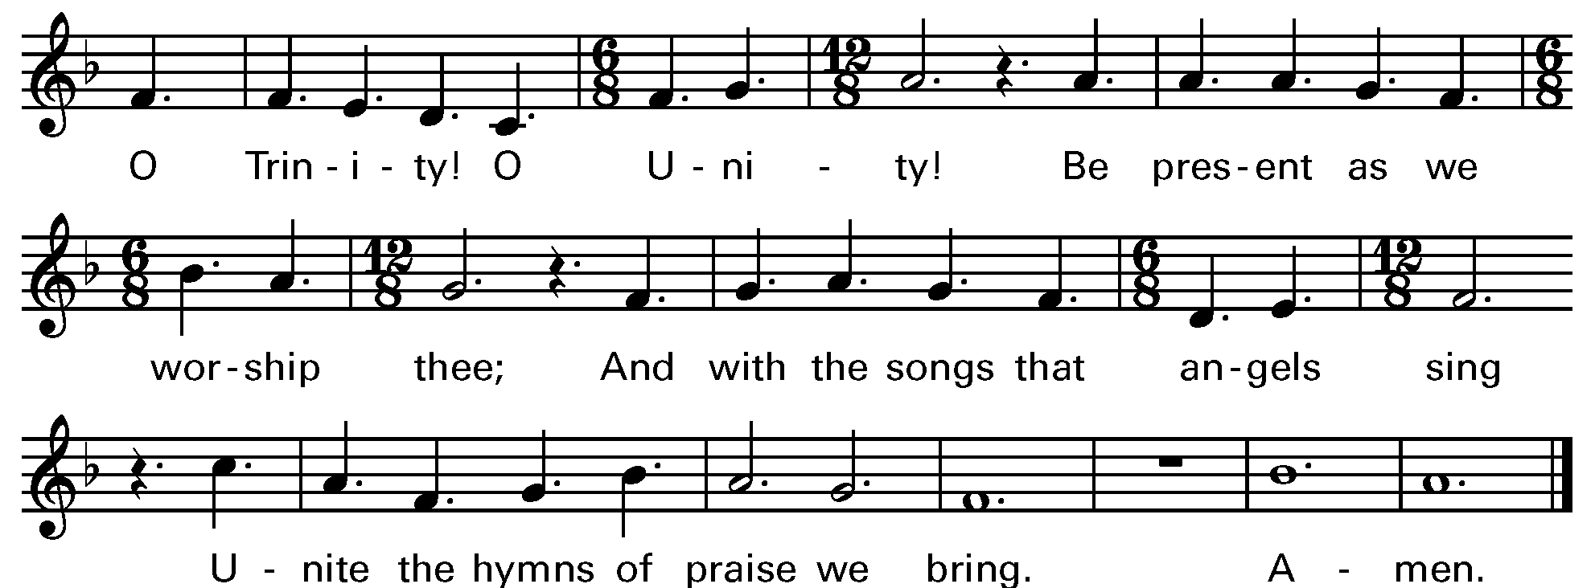

The Eucharistic Prayer: Prayer A or C may be used
The Eucharistic Prayer, or Great Thanksgiving, is the prayer of the church to invite Christ to be present in the elements of bread and wine. Now we come to the second act in the drama with the Liturgy of the Table. It is based on Jewish Fellowship meals, particularly the Passover observance. But this second half of the service is not communion in and of itself. It is the whole service, both acts of the drama, that make up the Eucharist.

Eucharistic Prayer A

Presider God is with you. or The Lord be with you.
People And also with you.
Presider Lift up your hearts.
People We lift them to the Lord.
Presider Let us give thanks to the Lord our God.
People It is right to give thanks and praise.
Then, facing the Holy Table, the Presider proceeds.

Presider It is right, and a good and joyful thing, always and everywhere to give thanks to you, Almighty God, Creator of heaven and earth.

Here a Proper Preface A, B, or C is said on all Sundays, and on other occasions as appointed.
Preface A. For you are the source of light and life, you made us in your image, and called us to new life in Jesus Christ our Lord.

Preface B. Through Jesus Christ our Lord; who on the first day of the week overcame death and the grave, and by his glorious resurrection opened to us the way of everlasting life.

Preface C. For by water and the Holy Spirit you have made us a new people in Jesus Christ our Lord, to show forth your glory in all the world.

The Presider then continues.
Presider Therefore we praise you, joining our voices with Angels and Archangels and with all the company of heaven, who forever sing this hymn to proclaim the glory of your Name:

Spoken: Holy, holy, holy
Holy, holy, holy Lord, God of power and might,
heaven and earth are full of your glory. Hosanna in the highest.
Blessed is the one who comes in the name of the Lord. Hosanna in the highest.
Sung: Holy, holy, holy Based on Hymn 362 Hymnal 1982
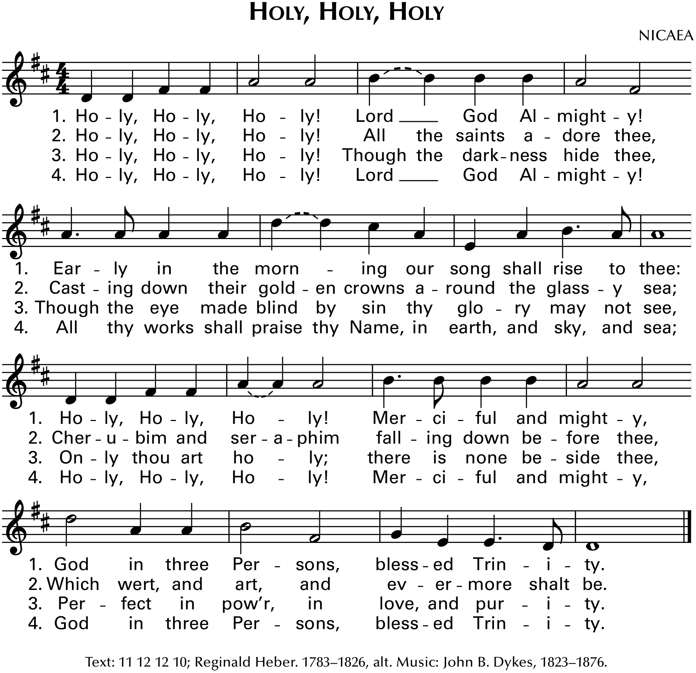

Then the Presider continues

Presider Holy and gracious God: In your infinite love you made us for yourself; and, when we had fallen into sin and become subject to evil and death, you, in your mercy, sent Jesus Christ, your only and eternal Son, to share our human nature, to live and die as one of us, to reconcile us to you, the God and maker of all.

Presider Jesus stretched out his arms upon the cross, and offered himself in obedience to your will, a perfect sacrifice for the whole world.

Presider On the night he was handed over to suffering and death, our Savior Jesus Christ took bread; and when he had given thanks to you, he broke it, and gave it to his disciples, and said, “Take, eat: This is my Body, which is given for you. Do this for the remembrance of me.”

Presider After supper Jesus took the cup of wine; and when he had given thanks, he gave it to them, and said, “Drink this, all of you: This is my Blood of the new Covenant, which is shed for you and for many for the forgiveness of sins. Whenever you drink it, do this for the remembrance of me.”

Presider Therefore we proclaim the mystery of faith:
People Christ has died. Christ is risen. Christ will come again.

Presider We celebrate the memorial of our redemption, Almighty God, in this sacrifice of praise and thanksgiving. Recalling Christ’s death, resurrection, and ascension, we offer you these gifts.

Presider Sanctify them by your Holy Spirit to be for your people the Body and Blood of your Son, the holy food and drink of new and unending life in Christ. Sanctify us also that we may faithfully receive this holy Sacrament, and serve you in unity, constancy, and peace; and at the last day bring us with all your saints into the joy of your eternal kingdom.

Presider All this we ask through Jesus Christ our Savior. By Christ, and with Christ, and in Christ, in the unity of the Holy Spirit all honor and glory is yours, Almighty God, now and for ever. AMEN.

Eucharistic Prayer C

Presider God is with you. or The Lord be with you.
People And also with you.
Presider Lift up your hearts.
People We lift them to the Lord.
Presider Let us give thanks to the Lord our God.
People It is right to give thanks and praise.

Then, facing the Holy Table, the Presider proceeds.

Presider God of all power, Source and Sustainer of the Universe, you are worthy of glory and praise.
People Glory to you for ever and ever.

Presider At your command all things came to be: shining light and enfolding dark; the vast expanse of interstellar space, galaxies, suns, and this fragile earth, our island home.
People By your will they were created and have their being.
Presider From the primal elements you brought forth the human race, and blessed us with the capacity for memory, reason, and skill. You made us the stewards of your creation. But we turned against you, and betrayed your trust; and we turned against one another.
People Have mercy, Lord, for we are sinners in your sight.

Presider Again and again, you called us to return. Through prophets and sages you revealed your righteous Law. And in the fullness of time you sent your eternal Word, born of your servant Mary, to fulfill your Law, opening for us the way of freedom and peace.
People By his blood, he reconciled us. By his wounds, we are healed.

Presider And therefore we praise you, joining with the heavenly chorus, with prophets, apostles, and martyrs, and with all those in every generation who have looked to you in hope, to proclaim with them your glory, in their unending hymn:

Spoken: Holy, holy, holy
Holy, holy, holy Lord, God of power and might,
heaven and earth are full of your glory.
Hosanna in the highest.
Blessed is the one who comes in the name of the Lord.
Hosanna in the highest.

Sung: Holy, holy, holy Based on Hymn 362 Hymnal 1982
Presider On the night he was betrayed Jesus took bread, said the blessing, broke the bread, and gave it to his friends, and said, “Take, eat: This is my Body, which is given for you. Do this for the remembrance of me.”

Presider After supper, Jesus took the cup of wine, gave thanks, and said, “Drink this, all of you: This is my Blood of the new Covenant, which is shed for you and for all for the forgiveness of sins. Whenever you drink it, do this for the remembrance of me.”

Presider Remembering now his work of redemption and offering to you this sacrifice of thanksgiving,
People We celebrate Christ’s death and resurrection as we await the day of his coming.

Presider Therefore, O God, we who have been redeemed by Jesus Christ, and made a new people by water and the Spirit, now bring before you these gifts. Sanctify them by your Holy Spirit to be the Body and Blood of Jesus Christ our Savior.

Presider Sanctify us also, and let the grace of this Holy Communion make us one body, one spirit in Christ, that we may worthily serve the world in his name.
People Risen Lord, be known to us in the breaking of the Bread.

Presider God of our ancestors; Redeemer and Mother of Israel; God and Abba of our Lord Jesus Christ: Open our eyes to see your hand at work in the world about us. Deliver us from the presumption of coming to this Table for solace only and not for strength; for pardon only and not for renewal. Accept these prayers and praises, Almighty God, through Jesus Christ our great High Priest, to whom, with you and the Holy Spirit, your Church gives honor, glory, and worship, from generation to generation. AMEN.

The Lord’s Prayer (Traditional)
The Lord’s Prayer follows in either traditional or contemporary language. The link between our daily bread, and the spiritual food we receive in the Eucharist is an ancient connection. In the Lord’s Prayer we ask for daily bread meaning the things we need to get through each day. But as a part of that, the bread also symbolizes God’s presence.

Presider As our Savior has taught us we are bold to pray.
People Our Father, who art in heaven, hallowed be thy name. Thy Kingdom come, thy will be done, on earth as it is in heaven. Give us this day our daily bread. And forgive us our trespasses, as we forgive those who trespass against us. And lead us not into temptation, but deliver us from evil. For thine is the kingdom, the power and the glory, for ever and ever. Amen.

The Lord’s Prayer (Contemporary)
Presider Let us pray in the way that our Savior has taught us.
People Our Father in heaven, hallowed be your name, your kingdom come, your will be done, on earth as in heaven. Give us today our daily bread. Forgive us our sins as we forgive those who sin against us. Lead us not into temptation but deliver us from evil. For the kingdom, the power, and the glory are yours now and for ever. Amen.

The Breaking of the Bread
The Presider breaks the consecrated bread in view of the assembly.
Presider Christ our Passover is sacrificed for us.
People Therefore let us keep the feast.

or

Presider By your hand you feed your people, food of angels, heaven's bread.
People For these gifts we did not labor; by your grace have we been fed.

Presider In this meal we taste your sweetness, bread for hunger, wine of peace.
People Holy word and Holy wisdom, satisfy our deepest needs.

Presider Send us now with faith and courage to the hungry, lost, bereaved.
People In our living and our dying we become what we receive.

or

Invitation to Communion
We partake in the Eucharist and are spiritually nourished, but it is not for our benefit alone. Communion enables us to return to the world with renewed vigor for proclaiming the Gospel in our words and in our lives. In the Eucharist, Christ’s presence both nourishes us and challenges us.

Presider The gifts of God for the people of God. [Take them in remembrance that Christ died for you, and feed on him in your hearts by faith, with thanksgiving.]

Or

The Presider may add
Presider These are God’s holy gifts, for you God’s holy people. [So come to this table you who have been here often and you who have not been here in a long time. You who have tried to follow Jesus and you who have failed. You who are full of faith and full of doubt. Come, it is Christ himself who invites you to meet him here.]

Sharing the Sacred Meal
This is Christ’s table and all are welcome and all are fed. All the baptized are invited to partake in the sacred meal. Please follow the movement to the altar.

Communion Hymns:
Hymns, anthems, or instrumental music may be played.

The Great Silence
Once all have received communion and the Holy Table has been cleared, the community observes a moment of silent reflection and prayer. The silence is begun and ended with the sound of a bell.

Presider Jesus said to his disciples, “Come away to a quiet place and rest for a while”. Therefore, let us now rest in Christ’s presence in the silence.

A prolonged silence is kept for a time. At a signal from the Presider the silence is broken.

Post Communion Prayer
After the Silence the Presider invites the congregation to stand and pray saying:
Presider God is with you.
People And also with you.
Presider Together, let us pray.

People God of grace, you renew us at your table with the bread of life and cup of salvation. May this food strengthen us in love and help us to serve you in each other. We ask this in the name of Jesus the Lord. Amen

Or

People Loving God, we give you thanks for restoring us in your image and nourishing us with spiritual food in the Sacrament of Christ’s Body and Blood. Now send us forth a people, forgiven, healed, renewed; that we may proclaim your love to the world and continue in the risen life of Christ our Savior. Amen.

The Blessing
The Presider blesses the people as a reminder of God’s extravagant love and invites us to go into the world to be God’s blessing.

Closing Song
We begin and end our time of worship by praising God through song and prayer.

Dismissal
As the celebration ends, we are charged to “Go in Peace to love and serve the Lord.” The Eucharist is therefore not an exclusive gathering that separates us from the world, but a challenge to reach out beyond our own church to the world around us.

Deacon Our worship is ended. Our service in the world begins. Go into the world to love what God loves. Go in Peace to love and serve the Lord.
People Thanks be to God.


Please return your bulletin for reuse next week.

Thank you for worshiping with us today.

We hope to see you again soon

as we offer Christ’s unfenced love to the world.

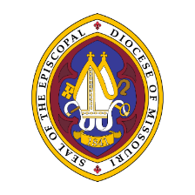
The Episcopal Diocese of Missouri Land Acknowledgement

In humility, we recognize and acknowledge that we in the Diocese of Missouri worship and live on the traditional ancestral lands of the Osage Nation, the Illiniwek/Peoria Tribe, the O-Gah-Pah (Quapaw) Tribe, the Otoe-Missouria Tribe, and other First Peoples. We recognize our mutual dependence upon and benefit from this land; we proclaim our solidarity with and our debt to the Peoples who first claimed and improved this land as their home. We acknowledge our complicity in the process of colonization that dispossessed the First Peoples from their ancestral lands. We affirm our commitment to stand with indigenous communities today and henceforth as they seek justice and resist continued threats to their sovereignty and humanity.

We are also cognizant that the history of The Episcopal Church is intertwined with the history of colonialism and slavery in the United States. More than four centuries ago, the first Africans were brought to the Americas and enslaved. Two centuries ago, enslaved and indigenous persons contributed to the exploration of this state by Lewis and Clark. Our state’s history is entangled with both the Missouri Compromise making this state officially a slave state, and the cases of Scott v. Emerson that petitioned for Dred and Harriet Scott’s emancipation. We acknowledge the tragic legacy of slavery in our diocese, and the blood, sweat, and tears of enslaved people that soak the earth beneath our feet in Missouri. This legacy persists today as we continue to work towards racial justice, equity, liberation, and community, here in Missouri and across The Episcopal Church.


We are a part of the Episcopal Diocese of Missouri,
which is made up of 42+ communities of faith, campus ministries, and ministry centers across the Eastern half of the state of Missouri.
We believe in a loving, life-giving and liberating God:
We believe God loves you -- no exceptions

Our Mission:
Walking humbly with God and our neighbor,
we seek justice, act with love, and live the Good News of Jesus.

Our Vision:
A world transformed by God's love, justice and peace.

